Module 1 - Assignment: Lab 1B - Getting Started Tutorial

EN.525.742 System-on-a-Chip FPGA Design Laboratory

# Purpose/Goals

The purpose of this tutorial is to familiarize you or provide you a refresher with the design tools, introduce the basic design flow we will be using in this course, and build a basic project with custom software running in the processing system (PS) and custom hardware in the programmable logic (PL).

# Table of Contents

This tutorial is a little long with all the screenshots, so here’s a table of contents to give an overview of the components and help you navigate around as you get into it. Alternatively, you can turn on the Navigation Pane to access this outline alongside the document as you read.

Purpose/Goals 1

Part I – Vivado & Vitis Installation 2

Part II – Simple PL design 5

Step 1 - Project Creation 5

Step 2 – Language Settings 8

Step 3 – Design Entry 9

Step 4 – Simulation 16

Step 5 – Synthesis / Implementation 19

Step 6 – FPGA Configuration 20

Step 7 – Design Update 22

Conclusion 22

Part III – Adding PS software 23

Step 1 – Adding a processing system 23

Step 2 – “Instantiating” the processing system in the top level FPGA design 33

Step 3 – Designing Software 36

Step 4 – Debugging 42

Step 5 – Writing some custom software 46

Step 6 – Booting from Flash 46

Booting from SD Card 46

Booting from QSPI 47

# Part I – Vivado & Vitis Installation

Vivado downloads are available from the [Xilinx website](https://www.xilinx.com/support/download.html). You may need to create a free account and provide some information for Xilinx to verify export compliance, but you will not need a license to use Vivado with the Zybo board/Zynq part in this course.

We want to download the unified installer for version **2024.2**. It is important that we all use this version as moving projects between versions can introduce a number of issues. The tools are available for Windows and Linux. The Windows installer includes everything you need for setup. If you want to install for Linux, it will likely work seamlessly if you have previously installed/used Vivado before, but if not there will be a few missing packages to install before Vivado/Vitis will run properly. If you are working on a Mac you will need to set up a virtual machine.

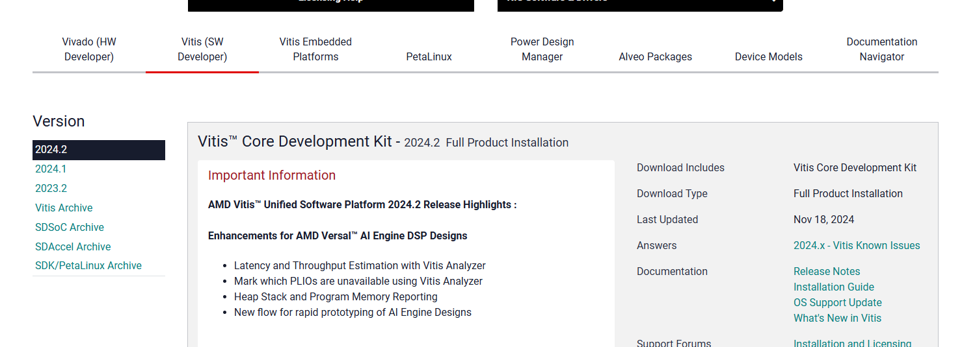

Download and run the installer for your operating system. If you notice any popups from your firewall asking whether the installer should be able to access the network, you need to say yes. So far, we’ve just downloaded a “small” package that will help us choose what to download and install. The complete tools installation is very large as we will learn shortly.

The first screen will be a welcome message. After you select next you will need to enter login information for the Xilinx account you used/created when downloading the installer.

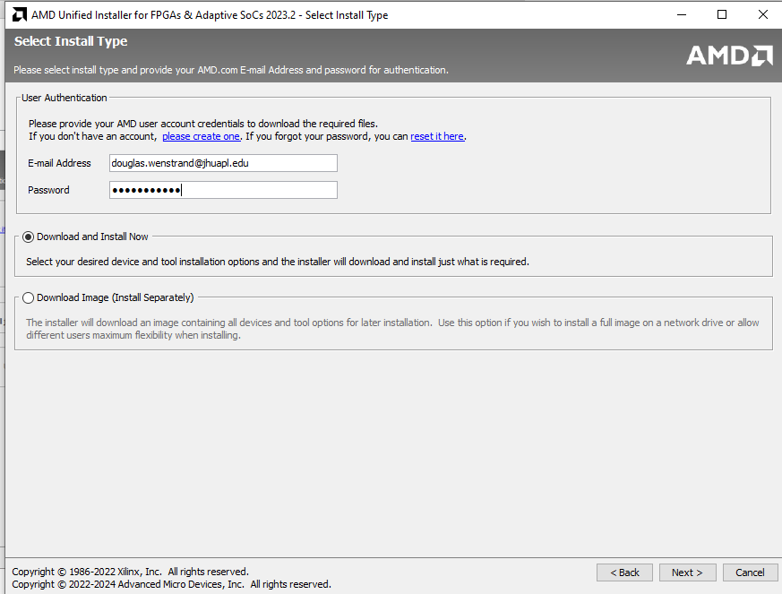

On the following page we want to choose to install the complete Vitis development kit with Vivado Design Suite.

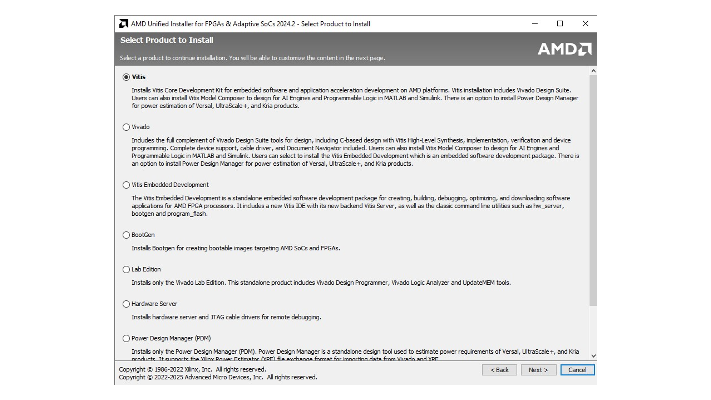

The components you should install to be able to complete our labs are

* “Vitis Unified Software Platform” (Vitis, Vivado, Vivado HLS)
* Vitis Model Composer
* DocNav
* Device support for “Zynq-7000”
* JTAG/”Cable” drivers (per the note make sure your board is powered off and/or disconnected during installation)

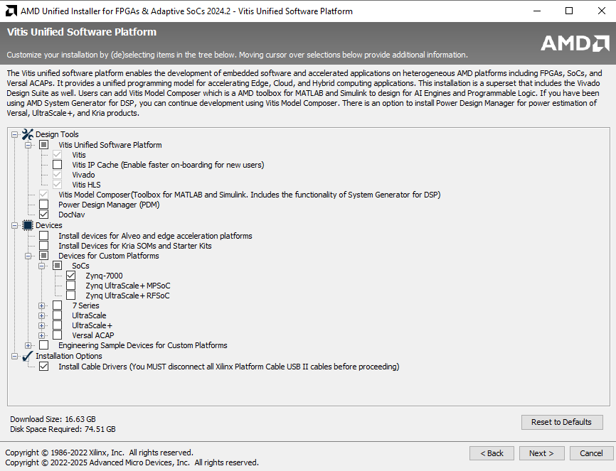

At this point you can leave the remaining options at their defaults and select next/accept through the remainder of the screens. If you have other Xilinx tool versions installed at the same installation location (eg. C:\Xilinx) don’t worry – the tools are grouped in subfolders by version and generally coexist without issue. One thing you ***don’t*** want to do is try to move the installation location to Program Files. Xilinx tools continue to have issues with spaces and special characters in paths. (This goes for your project directories too…stick to something simple like C:\work\lab1, C:\work\lab2, etc.). IMPORTANT : if you have a space in your user name in windows do not proceed. You should create a new account on your machine without spaces, and use that. Spaces in the user-name will seem fine now, but not later!

# Part II – Simple PL design

Here we will create an exceptionally simple FPGA design that lights the LEDs on the Zybo in a counting pattern incrementing at 2Hz. Note that like many advanced design tools Vivado provides a number of methods to accomplish many tasks including several of the steps provided in this section of the document. We’ll present one method for each step here. You may be familiar with or find others over the course of the semester.

## Step 1 - Project Creation

Start Vivado and select Create Project in the Quick Start panel

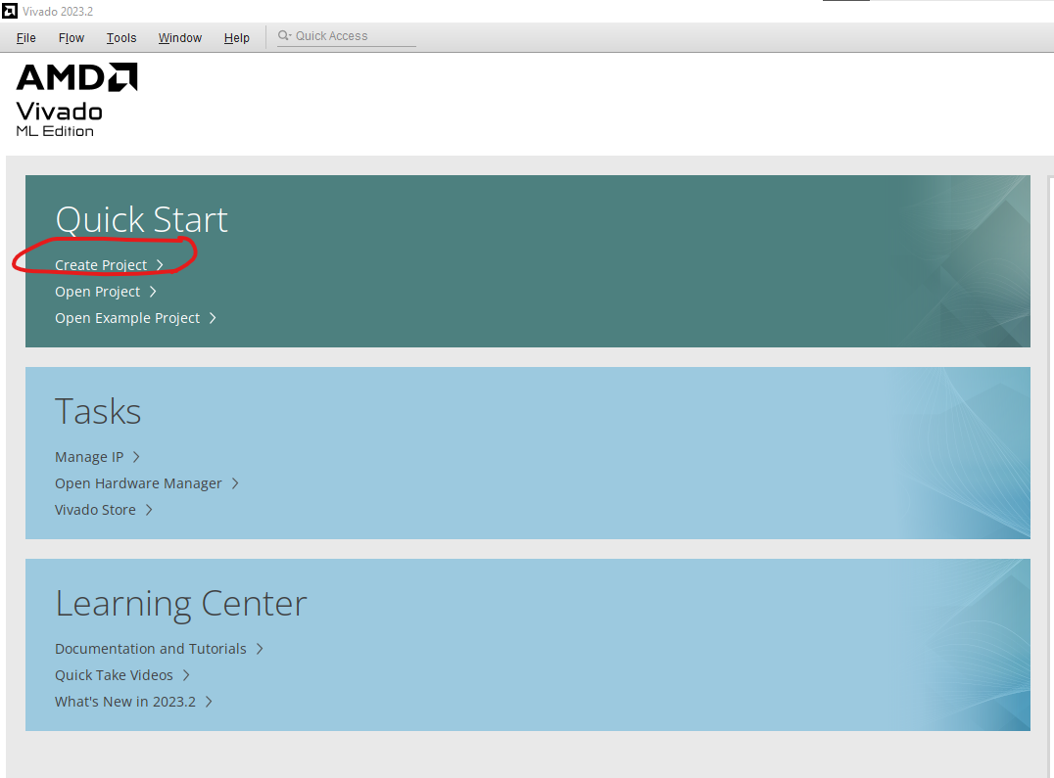

A popup will welcome you to the project creation wizard. Select next and choose a name and location for your Vivado project. I like to create a directory for each lab with a subdirectory named “vivado” which will hold the entire vivado project, lets create that first, and then put our new project inside the vivado directory. Make sure **not** to choose a path with any spaces in it or other “weird” characters, you will regret it later if you do.

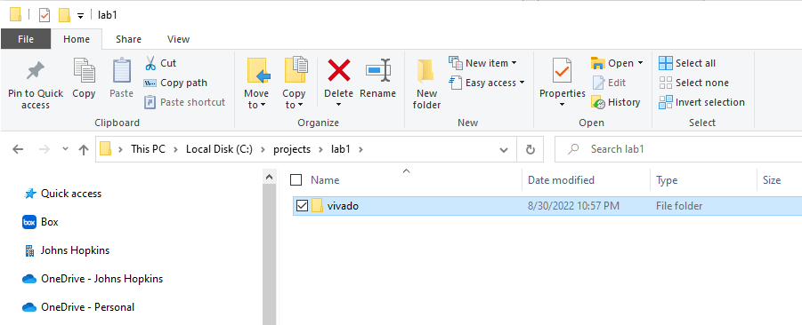

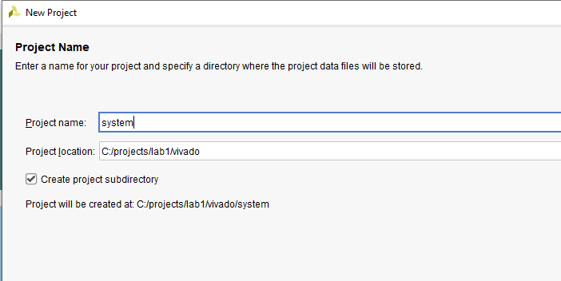

At the next dialog, select the option to create an RTL Project and skip specifying existing sources in the wizard. For this first project, we will add/create our sources later.

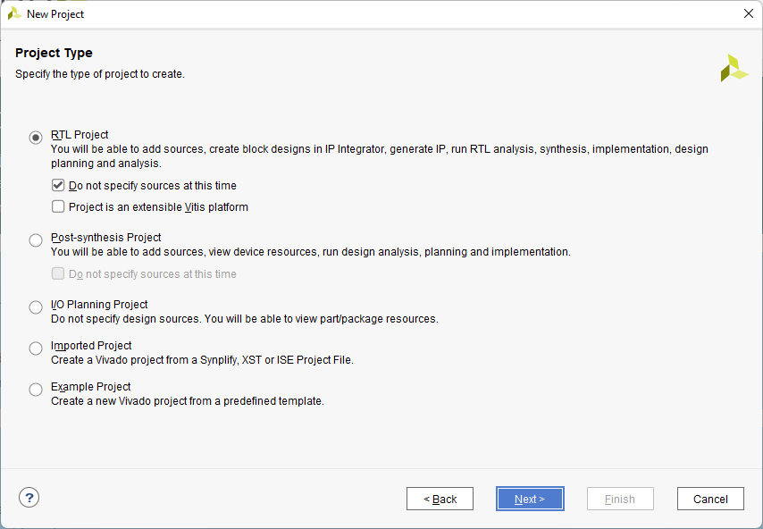

After this we need to tell the tools what device we are targeting. Specifying the board (Zybo Z7-20) rather than just the Zynq part (xc7z020clg400-1) on the Parts tab allows the tools to preconfigure the project with some settings such as DDR memory parameters that are specific to the board.

Select the Boards tab, then enter the text “zybo” in the search box. You should have a list of boards including the Zybo Z7-20. If you don’t, select the Refresh button to get an updated list of board definitions from the git repository where they are hosted[1]. In the status column you’ll have an icon to download the board definition. Once you have selected and downloaded the Next button should be enabled.

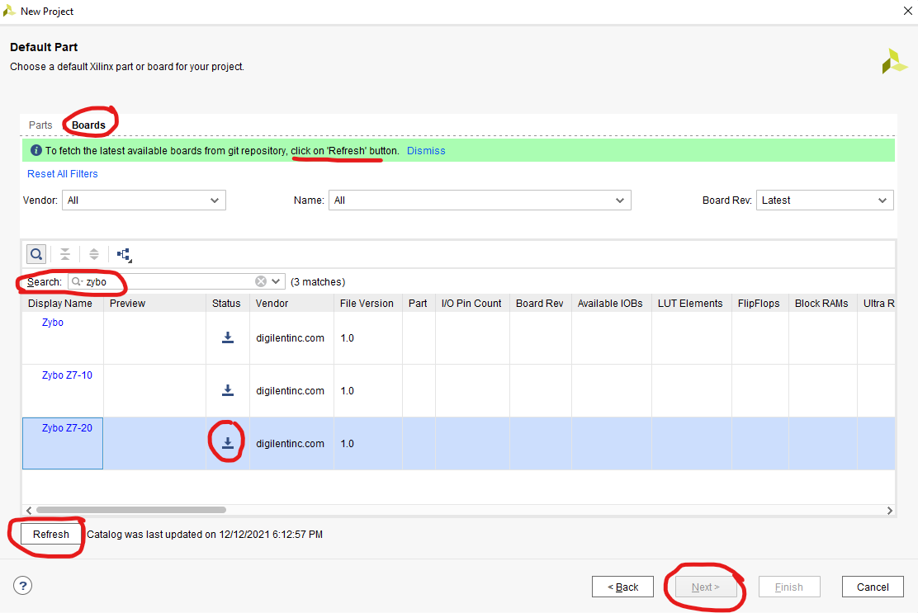

Now you should have a project summary with a Finish button.

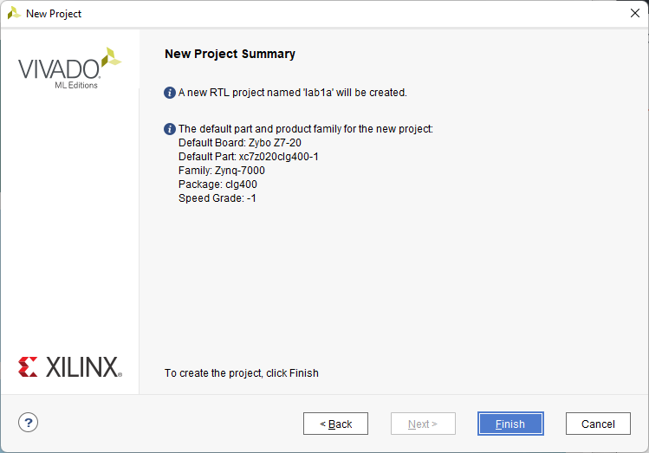

## Step 2 – Language Settings

Now we should have an empty project and an opportunity to check/fix two important settings that will help us down the road. If we open the menu Tools -> Settings you should have the following in the Project Settings -> General section.

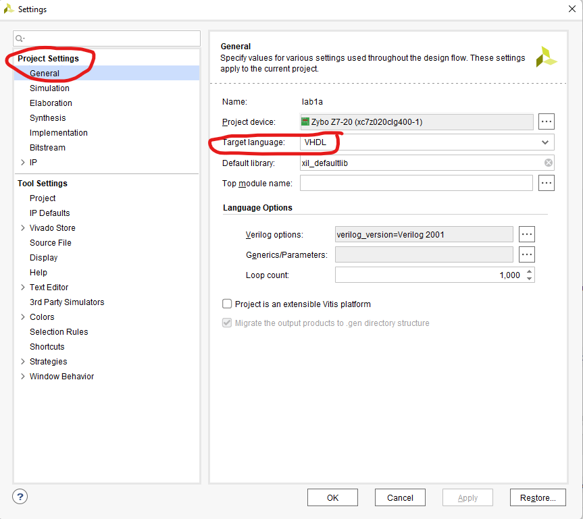

If the target language is not VHDL change it to VHDL now. Additionally, move to the Tool Settings -> Project section and do the same for the default target language for new projects so that you don’t have to worry about this in the future.

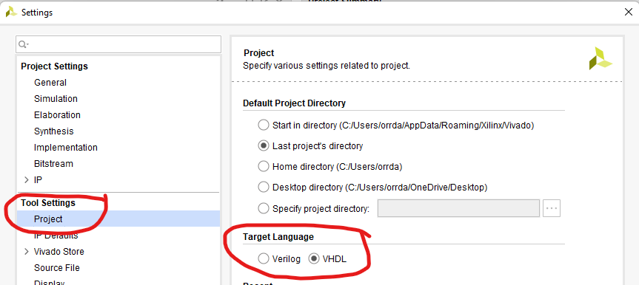

## Step 3 – Design Entry

Now that the project has been created, it is time to describe our design. This will be done using two HDL files: **toplevel.vhd** which we will create from scratch, and **clkdivider.vhd** which is provided for you in the canvas module: This way you’ll learn the steps to add both new and pre-existing code files to your project.

Download clkdivider.vhd to any convenient location, as Vivado will copy it to the project directory shortly, then select “Add Sources” under “Project Manager” in the Flow Navigator in the left-hand pane to get started.

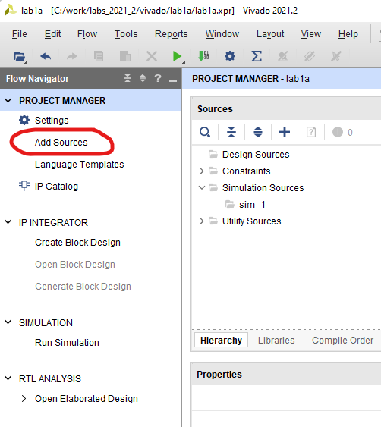

We’ll start with the existing source, clkdivider.vhd

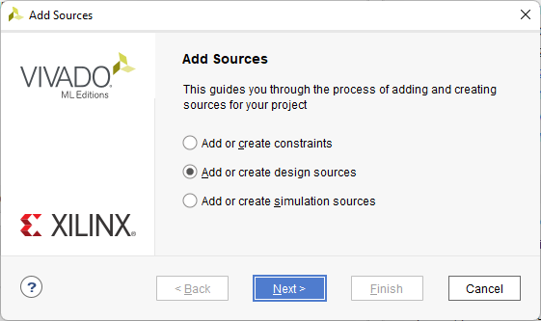

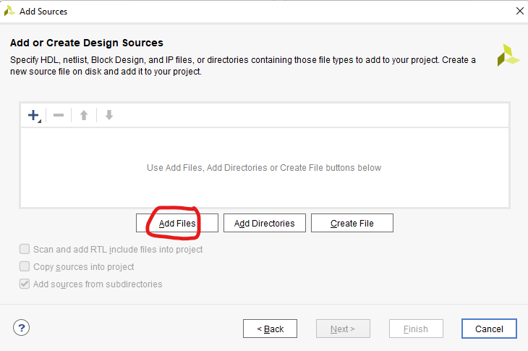

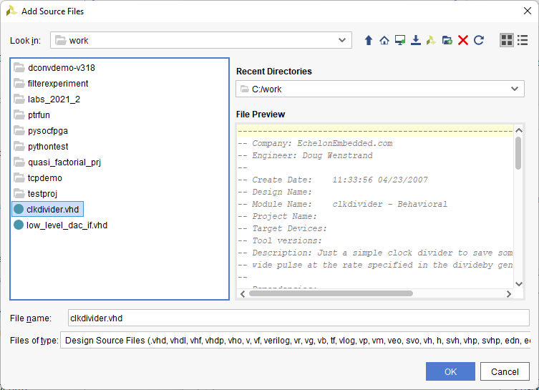

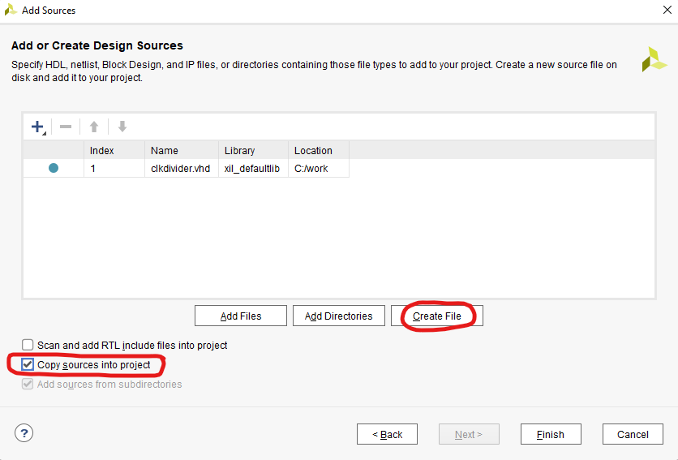

Make sure that you’ve checked “Copy sources into project” so that this existing file gets copied from wherever you saved it into your project directory. When we’re done with the lab you’re going to zip the whole project directory to turn in and we don’t want broken links to elsewhere on your computer when I try to open your projects.

Before you select finish to add the file(s) to our project, though, let’s also take care of the new source file toplevel.vhd we want to create. Select the “Create File” button and specify the name for your new file.

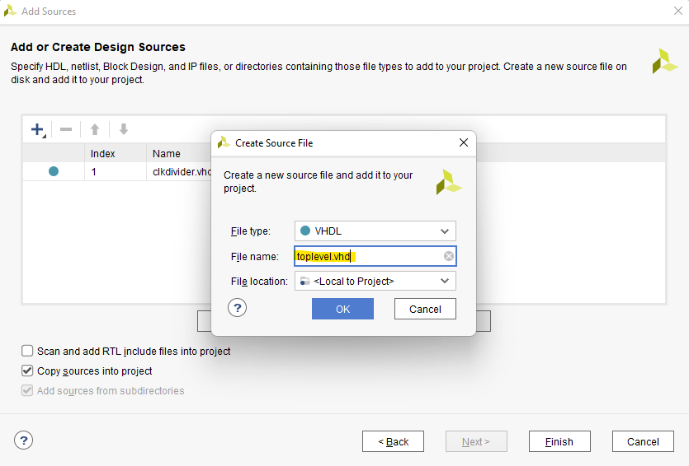

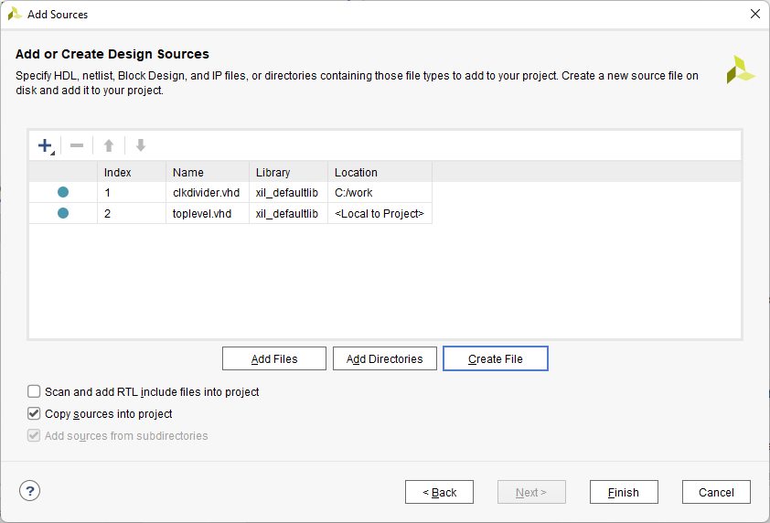

Now we have both files and we can select Finish. At this point, a popup dialog about “toplevel” (and any other new sources) will appear, asking us to specify ports. Whether to fill this out now is up to you. If you enter the ports here, you won’t have to type them in the entity description. I prefer to just type/paste in the text editor and I’m going to give you the code to paste, so let’s select through this box and acknowledge any warnings.

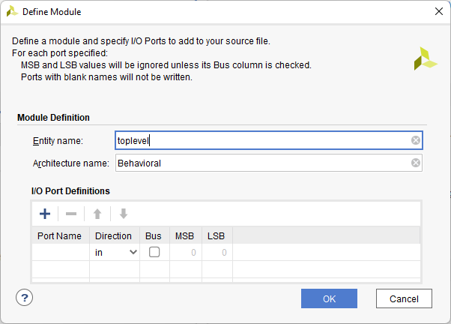

After you select Finish your project will contain two VHD files, clkdivider (which has something in it) and toplevel (which is essentially empty). Let’s now open and edit toplevel to do what we want.

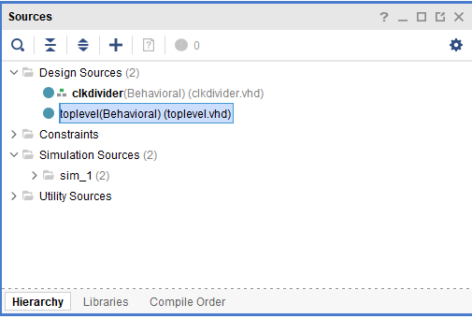

Copy and paste the code between the ---labels--- into toplevel.vhd replacing any template text that Vivado auto-generated for us.

-----Toplevel.vhd Code-----

**library** IEEE**;**

**use** IEEE**.**STD_LOGIC_1164**.ALL;**

**use** IEEE**.**NUMERIC_STD**.ALL;**

**entity** toplevel **is**

**Port** **(** reset_pb **:** **in** STD_LOGIC**;**

sysclk **:** **in** STD_LOGIC**;**

led **:** **out** STD_LOGIC_VECTOR **(**3 **downto** 0**));**

**end** toplevel**;**

**architecture** Behavioral **of** toplevel **is**

**signal** ctr **:** unsigned**(**3 **downto** 0**);**

**signal** rstn**,**ena_2Hz **:** std_logic**;**

**component** clkdivider **is**

**generic** **(**divideby **:** natural **:=** 2**);**

**port** **(** clk **:** **in** std_logic**;**

resetn **:** **in** std_logic**;**

pulseout **:** **out** std_logic**);**

**end** **component;**

**begin**

rstn **<=** reset_pb**;**

make2Hz**:** clkdivider **generic** **map** **(**divideby **=>** 62500000**)**

**port** **map** **(**clk **=>** sysclk**,** resetn**=>** rstn**,** pulseout **=>** ena_2hz**);**

-- just a silly counter for demo purposes

**process(sys**clk**,**rstn**)**

**begin**

**if** rstn**=**'0' **then**

ctr **<=** **(others=>**'0'**);**

**elsif** **rising_edge(sys**clk**)** **then**

**if** ena_2hz**=**'1' **then**

ctr **<=** ctr **+** 1**;**

**end** **if;**

**end** **if;**

**end** **process;**

led **<=** std_logic_vector**(**ctr**);**

**end** Behavioral**;**

-----End Toplevel.vhd Code-----

Once you save the toplevel.vhd file (if you’ve done this correctly) you should have the Sources view update to show that toplevel contains an instance of clkdivider called make2Hz.

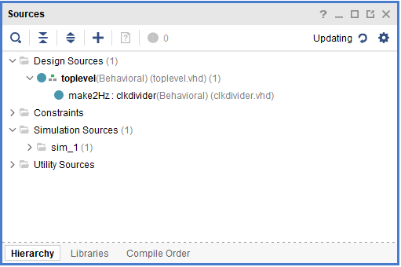

At this point, our behavioral design is complete, and we can move to Simulation and/or Synthesis.

## Step 4 – Simulation

Though this design is simple enough that we could skip simulation without much risk, we will go through the steps of simulating so that you are again familiarized with the tools.

Select “Add Sources” again. This time specify that you are adding **simulation** sources. This way the tools won’t try to synthesize the un-synthesizable testbench later.

Select “Create File” as before…

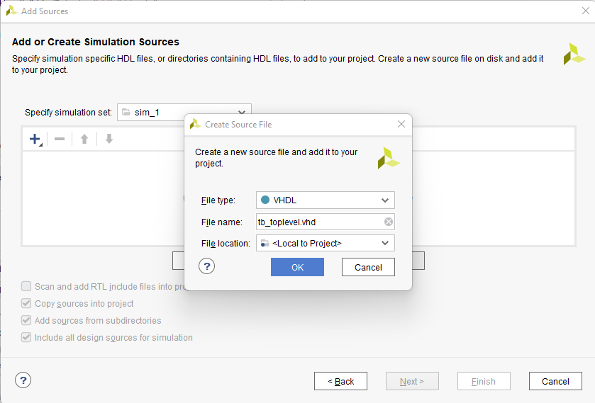

Then select through the remaining dialogs as before. Open the newly created file and replace its contents with the simple testbench code that follows. Note that a lot of this is boilerplate and a little [online utility for making that boilerplate](http://vhdl.lapinoo.net/testbench/tb.php) can be used.

----Begin testbench code----

**library** ieee**;**

**use** ieee**.**std_logic_1164**.all;**

**entity** tb_toplevel **is**

**end** tb_toplevel**;**

**architecture** tb **of** tb_toplevel **is**

**component** toplevel

**port** **(**reset_pb **:** **in** std_logic**;**

sysclk **:** **in** std_logic**;**

led **:** **out** std_logic_vector **(**3 **downto** 0**));**

**end** **component;**

**signal** reset_pb **:** std_logic**;**

**signal** clk_in **:** std_logic**;**

**signal** led **:** std_logic_vector **(**3 **downto** 0**);**

**constant** TbPeriod **:** time **:=** 8 ns**;**

**signal** TbClock **:** std_logic **:=** '0'**;**

**begin**

dut **:** toplevel

**port** **map** **(**reset_pb **=>** reset_pb**,**

sysclk **=>** clk_in**,**

led **=>** led**);**

TbClock **<=** **not** TbClock **after** TbPeriod**/**2**;**

clk_in **<=** TbClock**;**

stimuli **:** **process**

**begin**

reset_pb **<=** '0'**;**

**wait** **for** 232 ns**;**

reset_pb **<=** '1'**;**

**wait;**

**end** **process;**

**end** tb**;**

----End testbench code----

Again, the sources tree should update with the expected hierarchy.

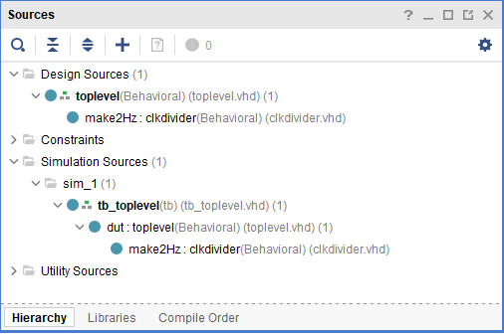

And now that you have a testbench, let’s simulate. **First, change the “divideby” generic in your top level VHD instantiation of the clkdivider from 62500000 to 62500. Otherwise, you will have to run the simulation for 500 ms just to have the LEDs move once!**

In the Flow Navigator (left hand pane) under Simulation, select “Run Simulation” and select “Behavioral Simulation”. The Xilinx simulator should start and it will have run for some default period of time (1us). The controls for this simulator should be exactly like what you used in 525.642, so this tutorial won’t dwell on the details. Type “run 10 ms” in the command window, or use the GUI to run the simulation for 10ms. You should notice the LEDs count from 0-F,0-4 in that time.

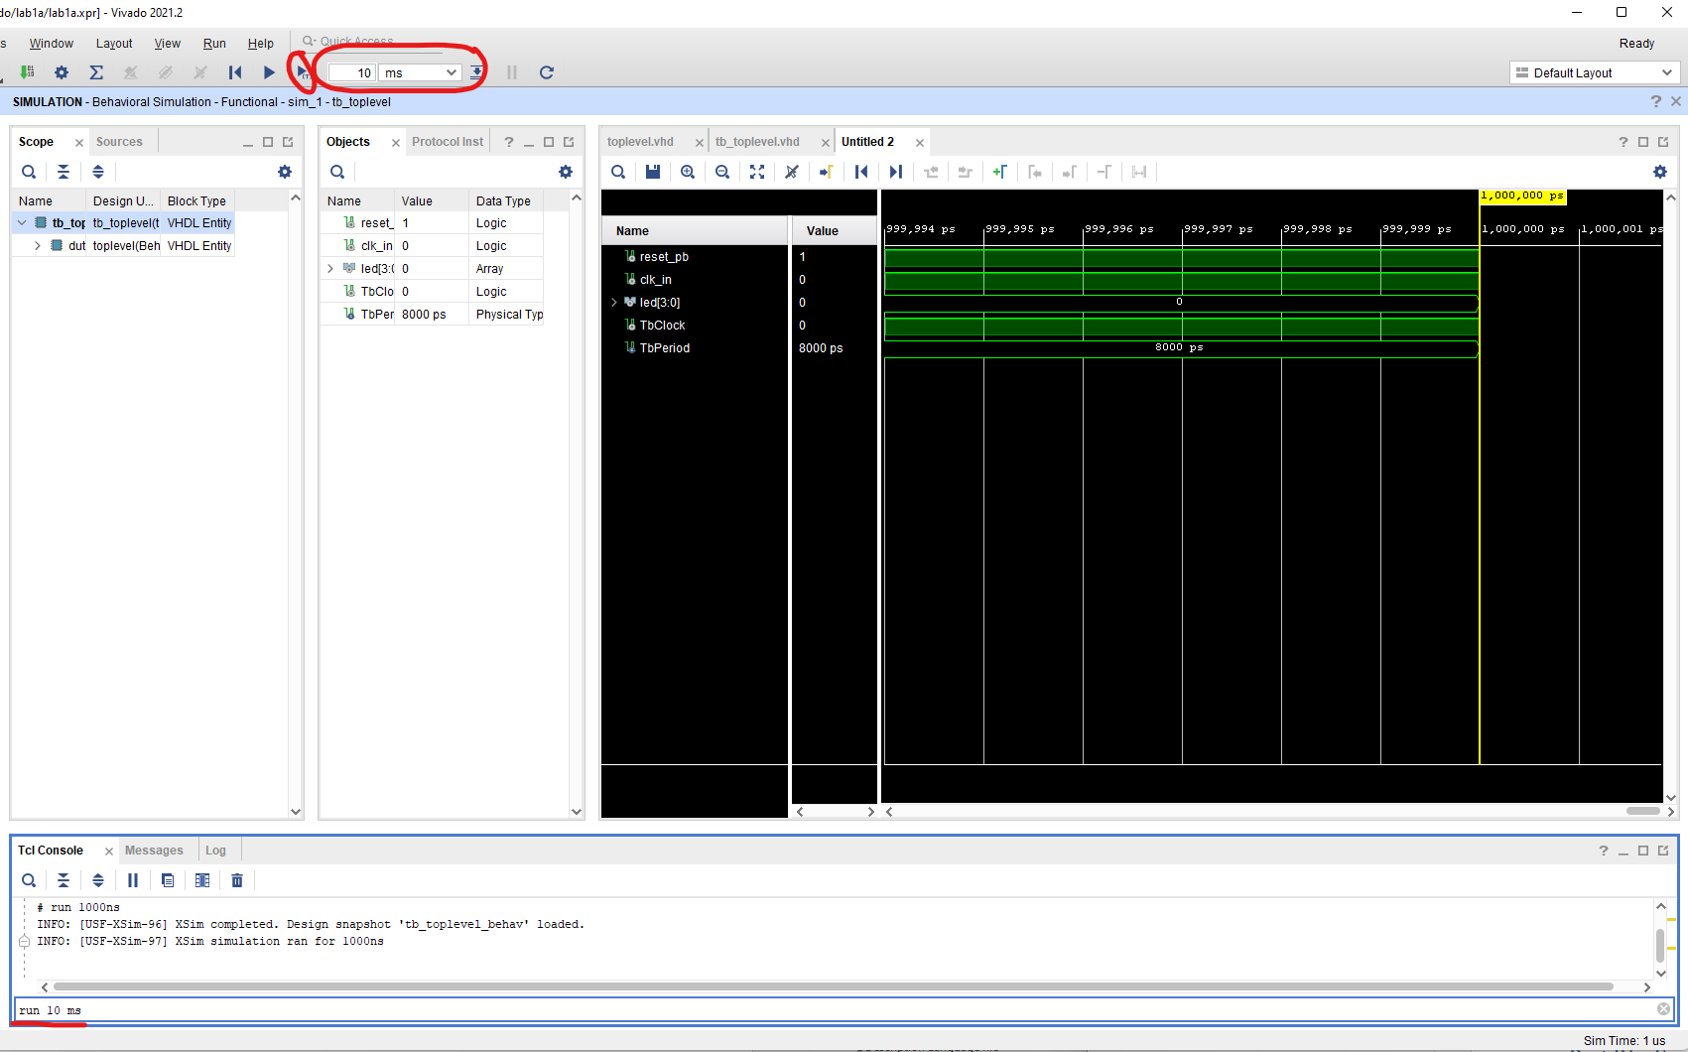

## Step 5 – Synthesis / Implementation

Assuming your design worked properly, you can now close the simulator and move on to Synthesis. **Remember to change your timebase back by changing the generic back to 62500000**. After saving, select “Run Synthesis” under Synthesis in the Flow Navigator to synthesize your design -- hopefully there will be no errors and you will be prompted for next steps.

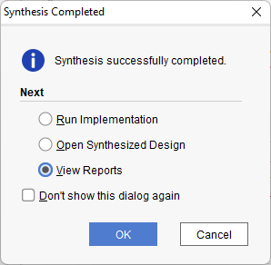

After synthesizing, you can review some reports if you like. Otherwise, we need to do a little preparation before we move on to implementation and put the design in our FPGA by setting some pin locations. We certainly don’t want these randomly chosen since external hardware like the LEDs are attached to specific fixed pins on our development board. There are a variety of ways to set these pin assignments, from looking at the schematic to reading the labelling on the board itself. Good documentation is available in this document and in the [Zybo Z7 Reference Manual](https://digilent.com/reference/programmable-logic/zybo-z7/reference-manual).

For this tutorial, however, we will take an easier approach and make use of the fact that Digilent has already created a constraints file for the board with all of the pin assignments defined. You can download the master constraints file from the Files->Class Materials section of the General channel in Teams or using [Digilent on GitHub](https://github.com/Digilent/digilent-xdc/blob/master/Zybo-Z7-Master.xdc).

Download the constraints file to a temporary location, and again select “Add Sources” in Vivado. This time you will select “Add or Create Constraints” and navigate to the downloaded XDC. Edit this file by simply uncommenting the pin assignments that you want to use and changing the name of the port to match your top-level design port name. Your XDC will end up looking like this (commented lines removed for clarity):

set_property -dict { PACKAGE_PIN K17 IOSTANDARD LVCMOS33 } [get_ports { sysclk }]; #IO_L12P_T1_MRCC_35 Sch=sysclk

create_clock -add -name sys_clk_pin -period 8.00 -waveform {0 4} [get_ports { sysclk }];

set_property -dict { PACKAGE_PIN K18 IOSTANDARD LVCMOS33 } [get_ports { reset_pb }]; #IO_L12N_T1_MRCC_35 Sch=btn[0]

set_property -dict { PACKAGE_PIN M14 IOSTANDARD LVCMOS33 } [get_ports { led[0] }]; #IO_L23P_T3_35 Sch=led[0]

set_property -dict { PACKAGE_PIN M15 IOSTANDARD LVCMOS33 } [get_ports { led[1] }]; #IO_L23N_T3_35 Sch=led[1]

set_property -dict { PACKAGE_PIN G14 IOSTANDARD LVCMOS33 } [get_ports { led[2] }]; #IO_0_35 Sch=led[2]

set_property -dict { PACKAGE_PIN D18 IOSTANDARD LVCMOS33 } [get_ports { led[3] }]; #IO_L3N_T0_DQS_AD1N_35 Sch=led[3]

This tells the synthesizer the proper location for all of your external ports and informs it of the speed of your main clock. Leaving the clock unconstrained would almost certainly be fine for this simple project, but it is always good practice to constrain the clock for static timing analysis. Future projects may not be placed/routed in a way that works at 125MHz if we don’t require it from the tools by setting a constraint. This is something that you don’t want to forget.

## Step 6 – FPGA Configuration

Now that the design is completed, select "Generate Bitstream" in the Left Pane. This should trigger the tools to go through Synthesis again (it is out of date since you changed the constraints) as well as Implementation and Bitstream generation. When completed it will create a file toplevel.bit to be used for configuration of the FPGA and you should have “write_bitstream Complete” at the top right corner of the Vivado window.

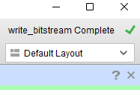

The Zybo contains onboard USB – JTAG. So, to load our bitfile to the FPGA (and use all other features which are available over JTAG) we need not carry around a Xilinx platform cable brick. Instead, we will just connect a USB cable from our computer to the **“PROG/UART”** Micro-USB jack on the board**. Make sure that the power switch on the Zybo is in the on position, the power jumper by the power switch is set to receive power over USB (Reference the provided picture), and the boot mode jumper above the PGOOD and PDONE LEDs on the right side is set to JTAG (rightmost two pins, not as pictured).**

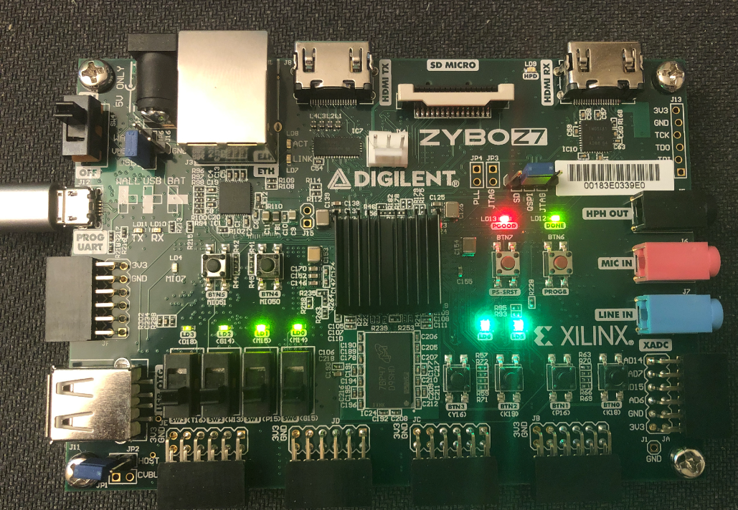

Programming in Vivado is done through the “Hardware Manager”. In the Flow Navigator under “Program and Debug” choose “Open Hardware Manager” then “Open Target” and select the target to open it. Then, select “Open Target”, “Open New Target”, and choose “Auto Connect.”

The hardware manager will be open, connected to the programming circuitry on the Zybo. In the screenshot provided, it has the xc7z020 fpga (the PL in our Zynq), and it is currently “Not Programmed.”

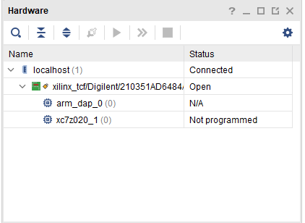

**Note:** If your boot mode jumper is not set to JTAG this will likely say “Programmed” as the board will have booted the factory demo image (which is flashing all of the LEDs for you) or a previous student image which could be doing any number of things. You can still program a new bitstream over JTAG but it’s best to fix the jumper and power cycle the board in case the image that booted configured any external devices in a way that you don’t know and aren’t controlling.

To program the FPGA with your new bitfile, select Program Device in the Flow Navigator below the option you used to open the target. The default bitfile chosen for you on the next dialog should be correct, so say “Program.”

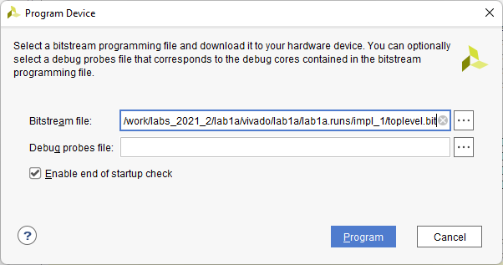

At this point - your design is on the FPGA, but no lights are blinking. Press and hold BTN0, (our “reset_pb”) and the lights will begin counting. We’ve just realized that we made a mistake in our reset polarity. We thought that the button was active low, but it was active high (should have looked more carefully at the schematic!). Let’s go through the correction of that error to practice the tools one more time.

## Step 7 – Design Update

First, change the rstn signal assignment in toplevel.vhd to read:

rstn <= not reset_pb ; -- this button is active high!

After saving toplevel.vhd, the top corner of the window should (eventually) update to indicate that the design has been changed

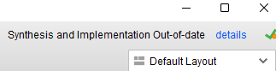

Select Generate Bitstream, and the whole process should run again. After bitstream completion select Program Device again to load your new bitstream (note the filename is the same, it has just been overwritten with your changes).

## Conclusion

At this point, you have successfully built a very small, simple FPGA design and tested it on your board. You have stepped through all the design phases including simulation and are capable of creating HDL based projects for the FPGA/PL.

# Part III – Adding PS software

Next, we’ll take what we’ve built in Part II and extend it with software running on the processing system (PS or “PS7”) in order to understand the design flow for integrating and debugging software as well as how to package a design into a binary that can be loaded from flash without use of JTAG/development tools.

## Step 1 – Adding a Processing System

In Part I, you completed an FPGA design that used a 125MHz external oscillator as a clock, and placed a counting pattern on the board LEDs. This step will extend that design, adding a microprocessor with a serial console, and a GPIO peripheral which will read the slider switches on the board, as well as take control of the LEDs to be lit under software control. To that end, we must first go through the construction and instantiation of that microprocessor block. This is done using a feature called “IP Integrator”. The IP Integrator is a sub-tool that allows the user to graphically connect together pieces of pre-packaged IP into a design that can be treated as a single block by the rest of your design. We are going to use it to build a block which has:

1. A representation of our processor/processing system (CPU, UART for printf statements...etc).
2. A GPIO (for reading switches and writing LEDs).

To start, select the “Create Block Design” in the left pane, give the block a name, and select OK to create your new block design.

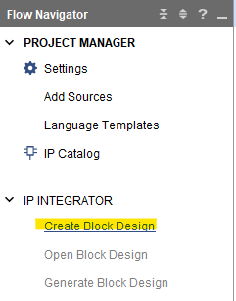 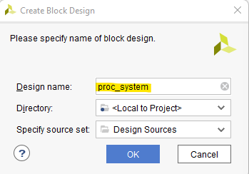

At this point you should have an empty block design page with a recommendation to select the button and add some IP. Let’s start by adding a PS7. Note that as discussed in lecture this IP is a little different than the others in that it won’t be built in fabric but instead is a description of the physical on-chip processor with which we will be interfacing.

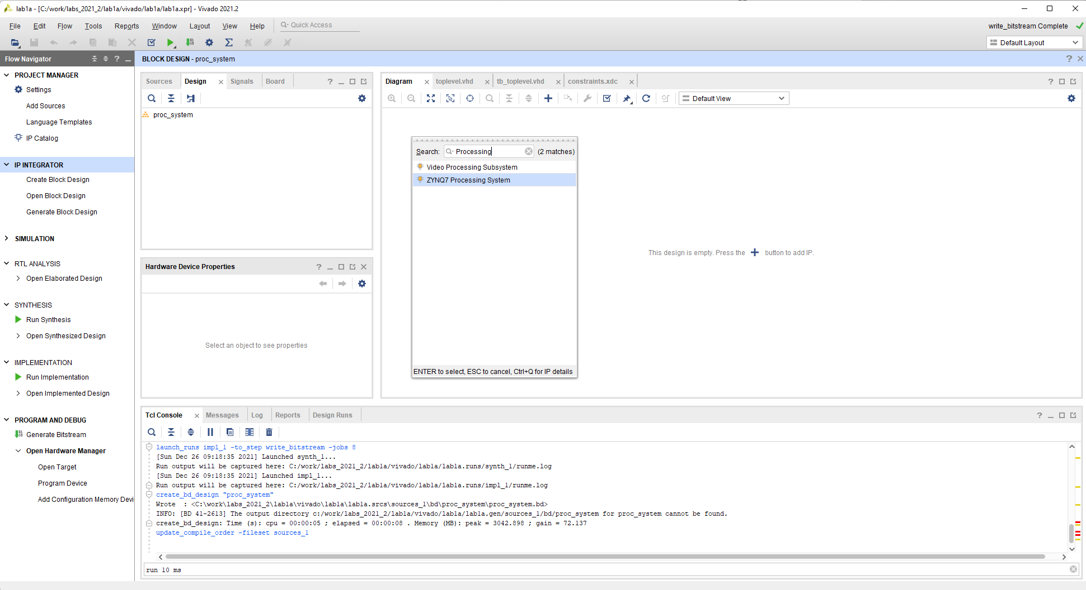

Once you add the IP you should have the symbol for the PS7, as well as a link from Designer Assistance to “Run Block Automation.”

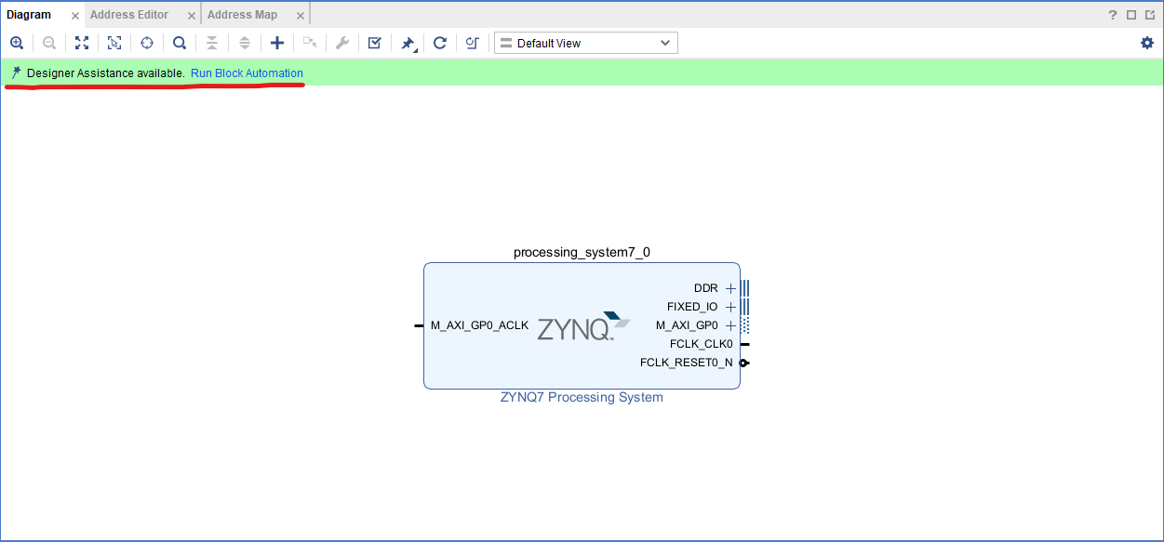

Let’s go ahead and do that. Select the link and you should have the following dialog. Unlike when/if you configured a Microblaze in 525.642 there isn’t a whole lot to do here. The processor exists physically on the chip so we don’t have to customize how it is implemented in hardware. We will get to set some (lots of?) registers that affect its behavior but that comes later. For now, we are simply saying that:

1. We want to bring out the IO and memory interfaces from the processor to ports on our block design.
2. We want to apply board presets (from the Zybo Z7-20 target that we chose way back in Part 2) to those configuration registers we’ll look at in a bit.

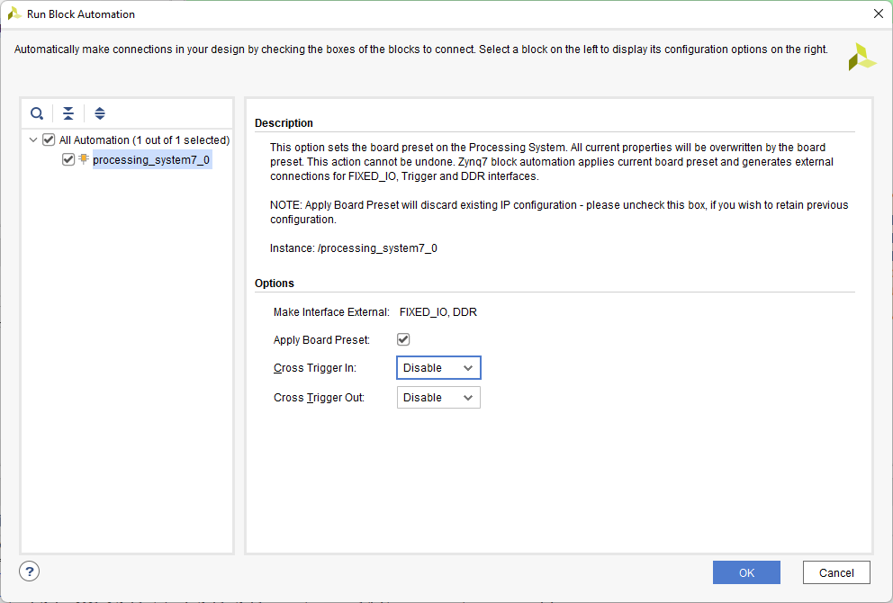

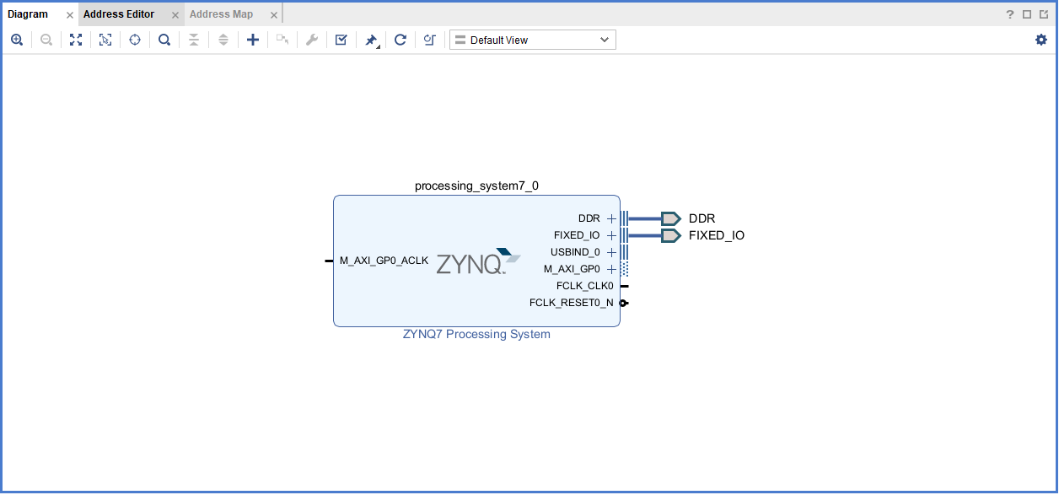

Note that the processor is providing an output clock FCLK_CLK0, synchronous to its own clock that can be used in the PL. It’s not too important now, but that clock defaults to 50MHz, and is changeable later depending on our purposes for it. It’s ok to leave it for now. Still, let’s select the block and take a quick look around.

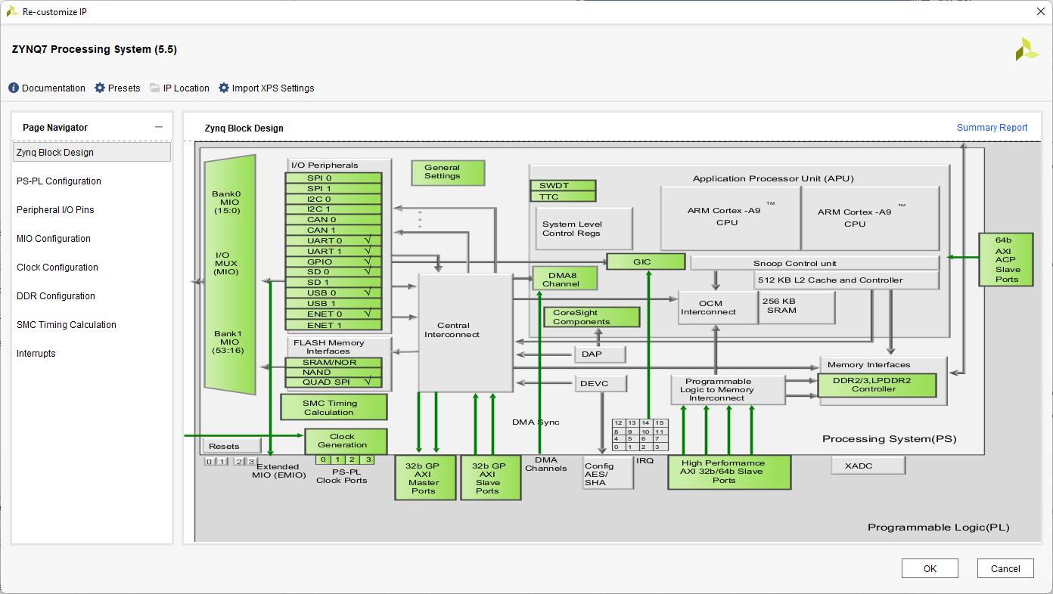

Here we have all of the various pieces of the processing system, remembering that they are hard-ip – meaning that these peripherals are actually on the silicon whether we ask for them or not. Green blocks can be selected to customize that section. Note – any changes you make here are actually register settings in the PS7. You are not changing the FPGA configuration/bit file. More on this later.

As an example, let’s look at the configuration of the DDR controller by double selecting the green box that says “DDR2/3/LPDDR2 Controller”. There are a wide variety of parameters that need to be programmed into the controller before it will successfully be able to use the external DDR (what part? How long are the traces?...etc.). Here is where those parameters would be entered. Fortunately, they have been set properly for us based on the board specification we provided when we ran block automation.

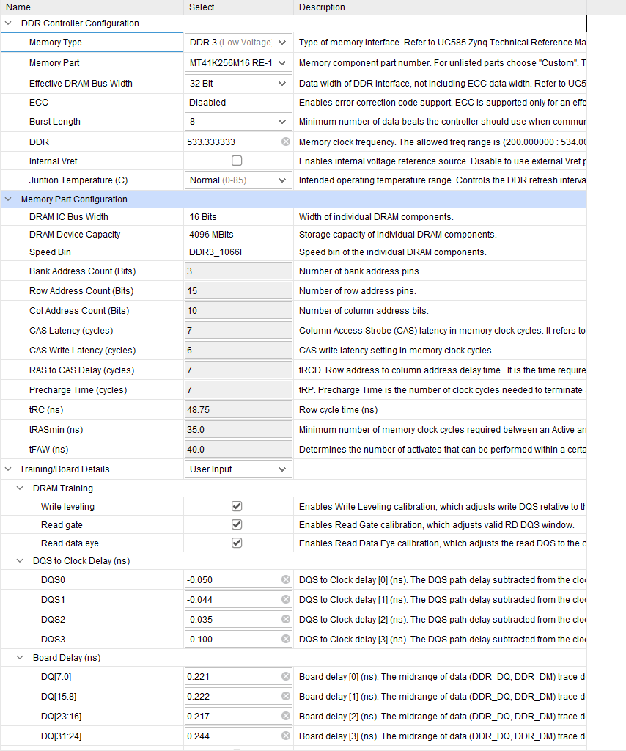

At some point you may have four “Critical Warning” messages about DDR signals. These are safe to ignore and would have appeared later even if we had left the clock setting as it was. The story behind them is in the [hardware errata](https://digilent.com/reference/programmable-logic/zybo-z7/reference-manual?redirect=1#hardware_errata) for our board.

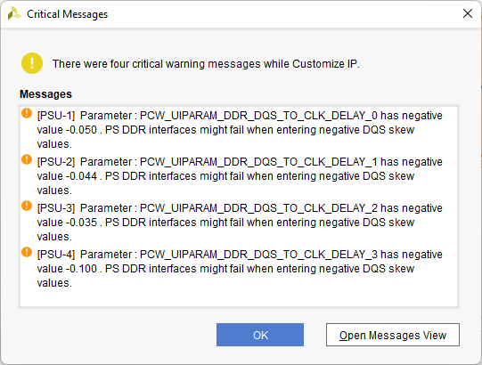

Now we have a processor but no peripherals to do anything with. Our hard processor core includes a lot of built-in peripherals, but we’re going to hold off on exploring those until a bit later. For now, while it may not be the most efficient use of resources, we are going to add a peripheral inside the PL that the PS can control over a standard interface named AXI. AXI will be a very common way to connect IP together, which we will discuss in further detail later in the class.

For this lab, we are going to add a peripheral whose job will be to handle general purpose IO (GPIO) like switches and leds. Select the “+” to add new IP again, and this time search for GPIO, and select the AXI GPIO.

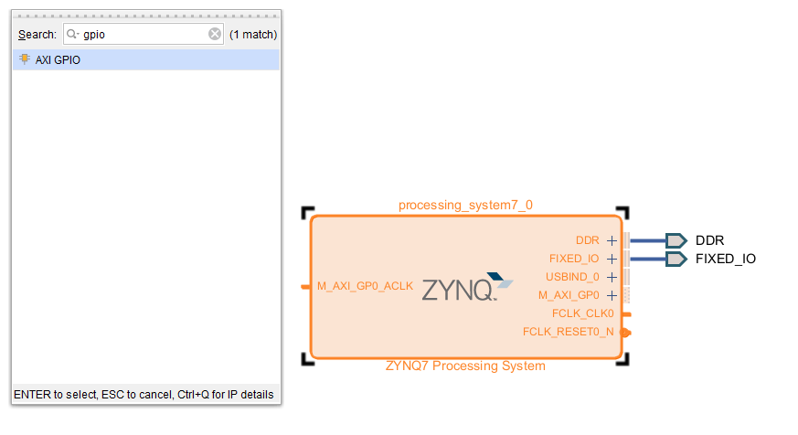

After adding the IP, the tool will prompt you like before to “Run Connection Automation”. We won’t do that quite yet. First, select (double-click) the newly added AXI GPIO peripheral and we will set it up the way we want it. Use the dropdowns to tell the tools we are going to connect GPIO to the slider (dip) switch inputs and GPIO2 to the led outputs.

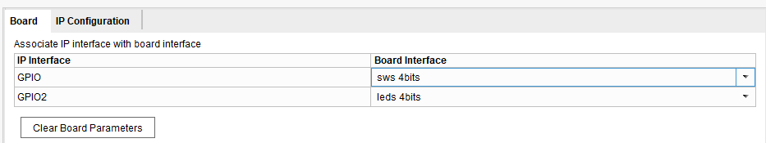

After you’ve finished editing the configuration of the GPIO peripheral, select “Run Connection Automation” to help make some of the connections for you. All these things can be done by hand, but it is much easier (as you’ll notice from the block diagram when you finish) to have the tools set things up in the most common configuration.

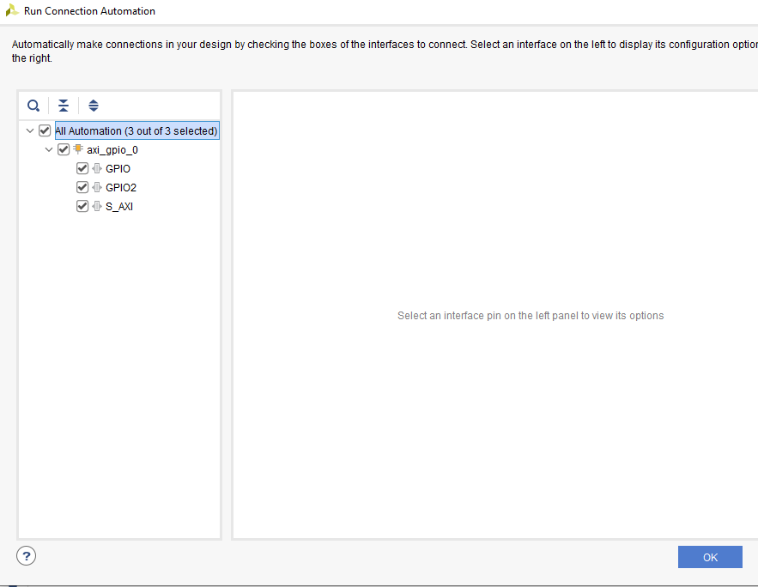

If you carefully read what it is offering to do for you, you’ll be more familiar with the process. It is offering to:

1. Hook the AXI slave interface on the GPIO peripheral to the AXI Master on the CPU (through a component called the AXI Smart Connect, which we will discuss later)
2. Make the IP interface of the GPIO external. In other words, take the GPIO signal (led and switch) signals which come in/out of the GPIO peripheral, and hook them to ports so that they can make it outside this block design and into your top level (where we will hook them to pins!)

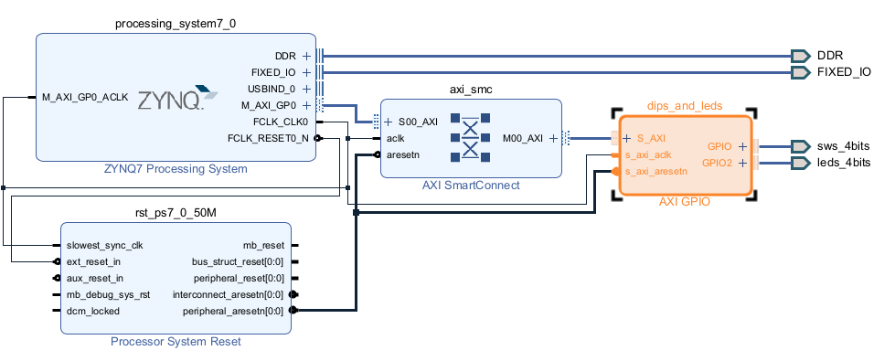

Take a minute to trace through the connections and review what the tools have done for you!

You can drag components around to get a better layout if you like. Additionally, (and this is useful) you can change the names of the peripherals to suit you. Later when we write software, we will be referring to the peripherals by name, so a name like “dips_and_leds” might be more convenient than “axi_gpio_0”. To change the name of a block, right click on the block and select “Block Properties”. For convenience, rename our gpio to “dips_and_leds”.

Finally, if you select the “+” next to the GPIO interface ports, you’ll notice that for GPIO2, a variety of different signals are coming in/out.

Conveniently using the board parameters, the tools have determined that you only need a 4-bit interface for both GPIO and GPIO2. They have also correctly determined that the switches are inputs.

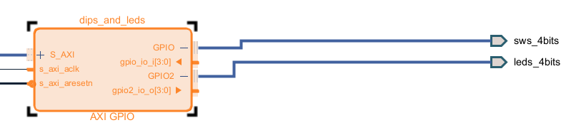

At this point, we are done with the block design! Much more can be done (we can rename the external ports, change our PS7 register customizations…etc.), but we will get into that later. For now, pressF6 to validate your design. This will check and make sure you haven’t left any important inputs hanging…etc. After that passes, Save (Ctrl+S) and close (if you like) the block design.

## Step 2 – “Instantiating” the Processing System in the Top-Level FPGA Design

Step 1 was fairly involved. Now all that is left to do is place this newly created block (proc_system) into our top level design.

The easiest top-level to do here is to bring up a template that the tools will create for you that shows how to easily instantiate the block design (it saves lots of typing). There are other ways to auto-generate a wrapper, but these add an extra layer of hdl files and complexity of choosing (or not choosing) to let the tools auto-update the wrapper when the block design changes. In our suggested approach, if you change the ports on the block design you just need to bring up the wrapper again, copy/paste the component definition, and update the port map accordingly with connections for your changed ports.

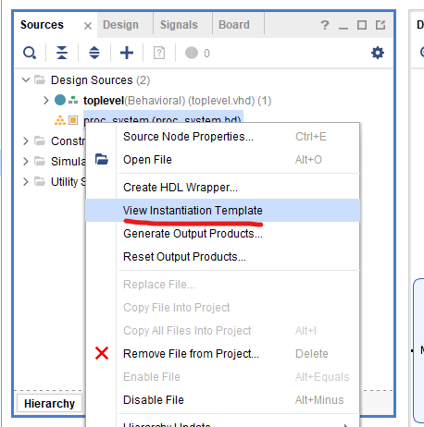

The template is an example of how to instantiate your proc_system in another design. We’ve got the 53 pin MIO, a clk for the PS, and a power on reset and system reset. All of these are connections from the PS to the outside world. They aren’t accessible in our PL design and unlike other signals from our PL they are there always, whether we like/need it or not, so we will put them in our top-level HDL to model that truth. Also on the component are our 4-bit input, 4-bit output. Finally, occupying all the space and looking complicated are the DDR pins. Though there are a lot of them, it is important to remember that the situation here is just the same as the other fixed IO. These pins are here, they are part of the PS7 and are hooked to specific pins on the package (you can’t change that). The board designer has hooked those pins to the memory already, so the fact that they are in your top level VHDL is only so that your HDL models what is actually there.

Grab the component declaration and copy that to the declarative section of your top-level design, it will look something like this:

component proc_system is

port (

DDR_cas_n : inout STD_LOGIC;

DDR_cke : inout STD_LOGIC;

DDR_ck_n : inout STD_LOGIC;

DDR_ck_p : inout STD_LOGIC;

DDR_cs_n : inout STD_LOGIC;

DDR_reset_n : inout STD_LOGIC;

DDR_odt : inout STD_LOGIC;

DDR_ras_n : inout STD_LOGIC;

DDR_we_n : inout STD_LOGIC;

DDR_ba : inout STD_LOGIC_VECTOR ( 2 downto 0 );

DDR_addr : inout STD_LOGIC_VECTOR ( 14 downto 0 );

DDR_dm : inout STD_LOGIC_VECTOR ( 3 downto 0 );

DDR_dq : inout STD_LOGIC_VECTOR ( 31 downto 0 );

DDR_dqs_n : inout STD_LOGIC_VECTOR ( 3 downto 0 );

DDR_dqs_p : inout STD_LOGIC_VECTOR ( 3 downto 0 );

FIXED_IO_mio : inout STD_LOGIC_VECTOR ( 53 downto 0 );

FIXED_IO_ddr_vrn : inout STD_LOGIC;

FIXED_IO_ddr_vrp : inout STD_LOGIC;

FIXED_IO_ps_srstb : inout STD_LOGIC;

FIXED_IO_ps_clk : inout STD_LOGIC;

FIXED_IO_ps_porb : inout STD_LOGIC;

sws_4bits_tri_i : in STD_LOGIC_VECTOR ( 3 downto 0 );

leds_4bits_tri_o : out STD_LOGIC_VECTOR ( 3 downto 0 )

);

Then grab the instantiation and paste it into your toplevel.vhd. We will need to replace all the signals on the right-hand side with our top-level signals (as I’ve done here because I’m going to shorten the names for the led, sw, and uart signals) if we don’t use matching names, but this still saves work. It should look something like this:

proc_system_i: component proc_system

port map (

DDR_addr(14 downto 0) => DDR_addr(14 downto 0),

DDR_ba(2 downto 0) => DDR_ba(2 downto 0),

DDR_cas_n => DDR_cas_n,

DDR_ck_n => DDR_ck_n,

DDR_ck_p => DDR_ck_p,

DDR_cke => DDR_cke,

DDR_cs_n => DDR_cs_n,

DDR_dm(3 downto 0) => DDR_dm(3 downto 0),

DDR_dq(31 downto 0) => DDR_dq(31 downto 0),

DDR_dqs_n(3 downto 0) => DDR_dqs_n(3 downto 0),

DDR_dqs_p(3 downto 0) => DDR_dqs_p(3 downto 0),

DDR_odt => DDR_odt,

DDR_ras_n => DDR_ras_n,

DDR_reset_n => DDR_reset_n,

DDR_we_n => DDR_we_n,

FIXED_IO_ddr_vrn => FIXED_IO_ddr_vrn,

FIXED_IO_ddr_vrp => FIXED_IO_ddr_vrp,

FIXED_IO_mio(53 downto 0) => FIXED_IO_mio(53 downto 0),

FIXED_IO_ps_clk => FIXED_IO_ps_clk,

FIXED_IO_ps_porb => FIXED_IO_ps_porb,

FIXED_IO_ps_srstb => FIXED_IO_ps_srstb,

leds_4bits_tri_o(3 downto 0) => led(3 downto 0),

sws_4bits_tri_i(3 downto 0) => sw(3 downto 0)

);

Add the new signals to your top level entity definition:

entity toplevel is

Port ( --DOES NOT NEED CONSTRAINTS

DDR_addr : inout STD_LOGIC_VECTOR ( 14 downto 0 );

DDR_ba : inout STD_LOGIC_VECTOR ( 2 downto 0 );

DDR_cas_n : inout STD_LOGIC;

DDR_ck_n : inout STD_LOGIC;

DDR_ck_p : inout STD_LOGIC;

DDR_cke : inout STD_LOGIC;

DDR_cs_n : inout STD_LOGIC;

DDR_dm : inout STD_LOGIC_VECTOR ( 3 downto 0 );

DDR_dq : inout STD_LOGIC_VECTOR ( 31 downto 0 );

DDR_dqs_n : inout STD_LOGIC_VECTOR ( 3 downto 0 );

DDR_dqs_p : inout STD_LOGIC_VECTOR ( 3 downto 0 );

DDR_odt : inout STD_LOGIC;

DDR_ras_n : inout STD_LOGIC;

DDR_reset_n : inout STD_LOGIC;

DDR_we_n : inout STD_LOGIC;

FIXED_IO_ddr_vrn : inout STD_LOGIC;

FIXED_IO_ddr_vrp : inout STD_LOGIC;

FIXED_IO_mio : inout STD_LOGIC_VECTOR ( 53 downto 0 );

FIXED_IO_ps_clk : inout STD_LOGIC;

FIXED_IO_ps_porb : inout STD_LOGIC;

FIXED_IO_ps_srstb : inout STD_LOGIC;

--NEEDS CONSTRAINTS

reset_pb : in STD_LOGIC;

sysclk : in STD_LOGIC;

led : out STD_LOGIC_VECTOR ( 3 downto 0 );

sw : in STD_LOGIC_VECTOR ( 3 downto 0 )

);

end toplevel;

For convenience, I’ve grouped the signals at the top level into signals that need constraints (actual PL signals that need to get routed to a pin) and signals that don’t (signals that are physically routed from the PS7 but described here anyway to make the hardware description complete).

Note that I’ve changed the names of the LED and switch signals from the template for simplicity (and to match our constraints file). **And since we have just hooked LEDs to the block design peripheral we need to comment out our HDL that drives the LEDs from the counter - having them driven by the counter as well would be an error (multi-source)**.

Now that we have created new top level signals (SW), we will need to add new pin assignments to the XDC file. Lets just edit the text file to uncomment these lines:

set_property -dict { PACKAGE_PIN G15 IOSTANDARD LVCMOS33 } [get_ports { sw[0] }]; #IO_L19N_T3_VREF_35 Sch=sw[0]

set_property -dict { PACKAGE_PIN P15 IOSTANDARD LVCMOS33 } [get_ports { sw[1] }]; #IO_L24P_T3_34 Sch=sw[1]

set_property -dict { PACKAGE_PIN W13 IOSTANDARD LVCMOS33 } [get_ports { sw[2] }]; #IO_L4N_T0_34 Sch=sw[2]

set_property -dict { PACKAGE_PIN T16 IOSTANDARD LVCMOS33 } [get_ports { sw[3] }]; #IO_L9P_T1_DQS_34 Sch=sw[3]

Save the constraints and your hardware design is complete. Select Generate Bitstream to run through synthesis, implementation, and bitstream generation. Wait for this to complete, but don’t program the device just yet – our hardware design no longer does anything of interest on it’s own.

## Step 3 – Designing Software

At this point, you have a complete hardware design that is ready to do just about anything that the software would like (provided that you only want to read switches, write LEDs, and communicate via. UART).

Note, however, that we did a bunch of things in Vivado that our software development environment probably should know about:

* We built peripherals into our programmable logic and attached them to the processor’s AXI interface.
* We assigned memory mappings (the tools did it automatically but more on that in later labs).
* We specified configuration settings that are controlled by registers in the processor.

The tools can provide us drivers for the peripherals, automate the programming of the configuration registers, and more if we formulate a good description of all that we’ve done to hand off to the software development environment.

To do this, we choose a menu option File -> Export -> Export Hardware. This opens a wizard to “Export Hardware Platform.” From here things start to diverge from what you may be familiar with in 525.642.

In the second wizard screen you are asked to select the type of output we want to generate. We’ll select “Include bitstream” to package the FPGA configuration with our hardware description. This will make programming easier later on.

In the following dialog you can accept the default settings to create toplevel.xsa at the route of your *Vivado* project directory. This .xsa is really just a zip file with a different extension that contains several files, some of which we’ll be exploring when we get into the software tools. We should think of this XSA file as a description of the hardware, and it will be packaged along with a bitfile which will implement the PL portion of said hardware. In other words, the XSA file is all that the hardware designer needs to give to a software developer so that they could develop software for the system that was just designed! The default location that it wants to save the XSA file should be just fine.

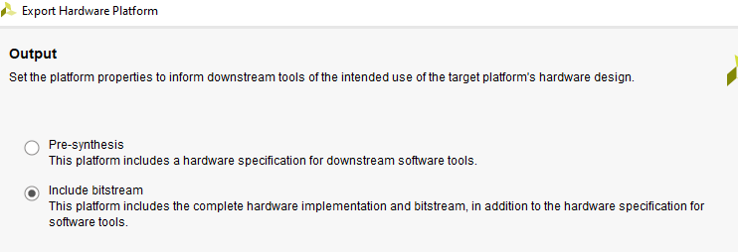

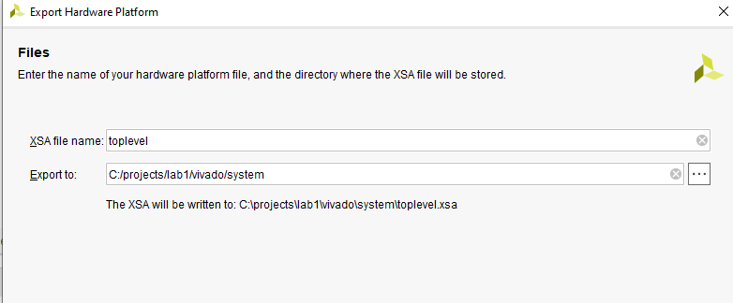

Select Next, review the summary of what the wizard is about to do, and select Finish.

Once the hardware description (“platform”) has been generated and saved we are ready to switch to our software development environment “Vitis.” I find it best to launch this tool independently from your start bar.

Once the hardware description (“platform”) has been generated and saved we are ready to switch to our software development environment “Vitis.” **Note: In 2024.2 there are two different versions of Vitis: (Vitis Unified IDE, and Vitis Classic) we will want to run “Vitis Unified IDE”. Launch Vitis 2024.2 from your start bar, or from inside Vivado you can select Tools -> Launch Vitis IDE.**

When Vitis appears, you will be presented with an option to “Set Workspace”. The first dialog that appears will ask you to select a workspace. Xilinx recommends against placing this workspace inside your Vivado project directory and the default location isn’t a great idea either because a) we want to have separate workspaces for each project/lab and b) we would like this workspace to be neatly grouped with the vivado project it goes with. So, instead create a folder named “vitis” right next to the vivado folder which contains your hardware design. In my case that looks like this: c:\projects\lab1\vitis

(remember the Vivado project for the hardware was in my case at: C:\projects\lab1\vivado).

At this point, the Vitis screen looks rather boring, and is complaining that there is nothing in our workspace. This should be no surprise, since we haven’t done anything yet, but let’s get started and add some software! The first step will be to tell Vitis about the processor system that we will be developing software for. This is named the “Platform”. So, we will select the entry that says “create platform component”.

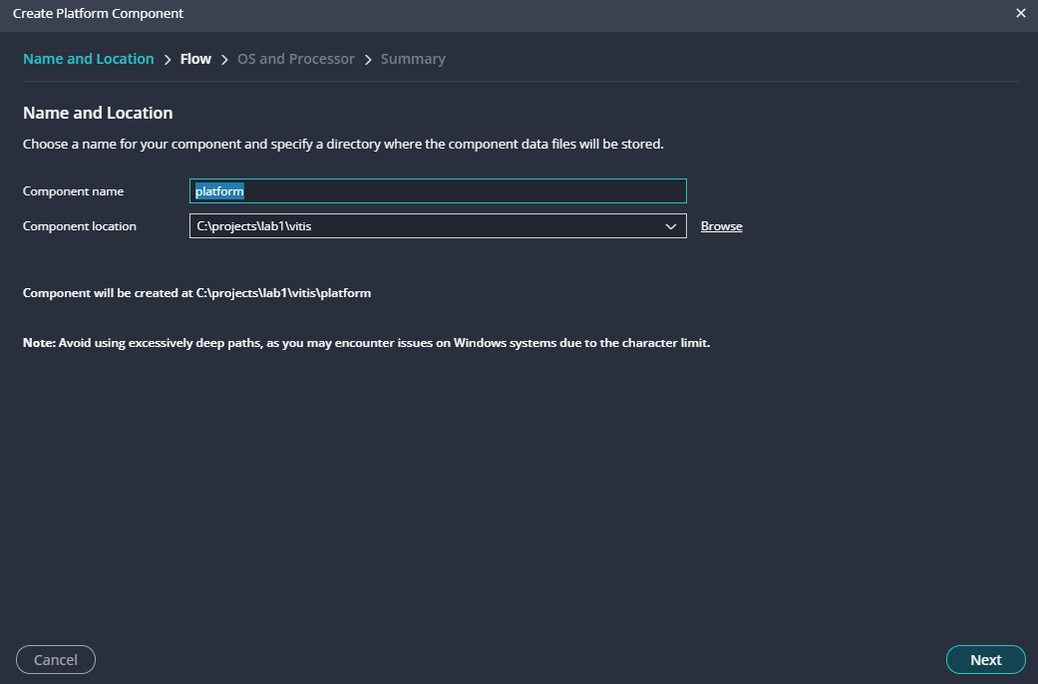

The next screen will ask you about your hardware design. This is where you will select “Browse” and navigate to the XSA file that you exported from Vivado after you were finished with the hardare design. That should be in your “vivado” directory and may not match my path.

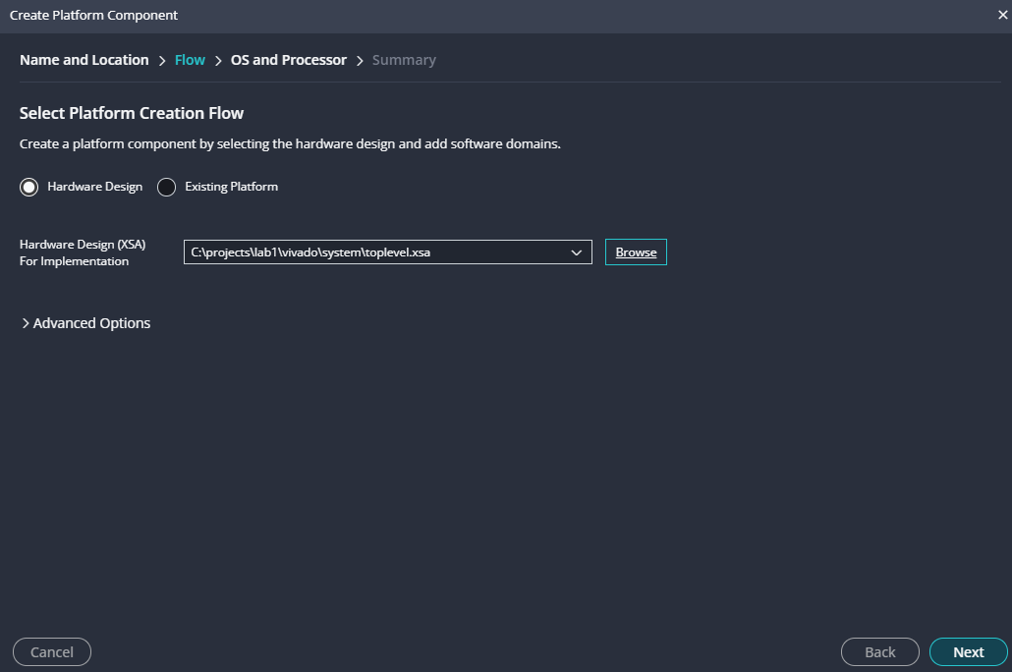

Finally, you will be asked about which processor from your design you are developing software for (answer = ps7_cortexa9_0), and if there is an OS (no). So, you will leave the defaults as shown on the next screen.

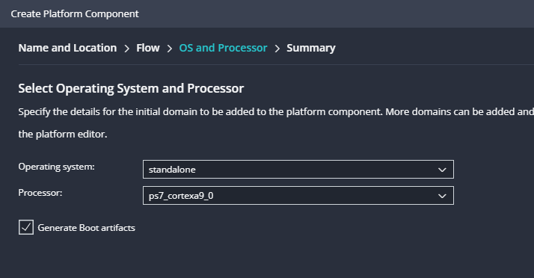

Note that the “Generate Boot Artifacts” is checked, this will be important later when we are ready to submit our completed project.

Now that Vitis knows about the hardware in our system, it is time to develop our actual software application. Select: “File -> New Example”. On the left-hand pane, you will be presented with a list of millions of example programs, select “Hello World”.

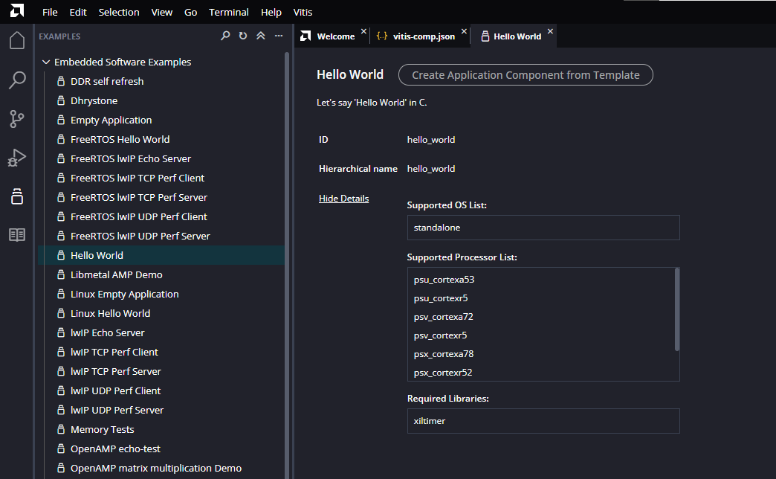

After selecting “Create Application Component from Template”, you will be presented with two dialogs. The first will ask you to name your new program. Here, the defaults are fine (hello_world).

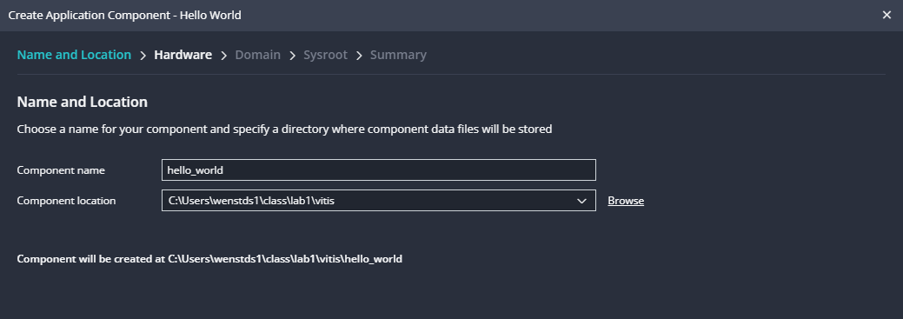

The next dialog will ask you to select the “platform” that you are targeting. In this case, that will be the one we just created, “platform”.

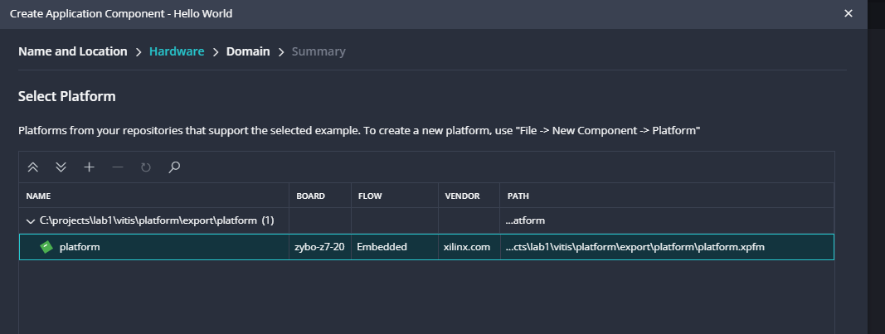

Similarly, it will ask for a “domain”, which is also the existing no-os “standalone” domain.

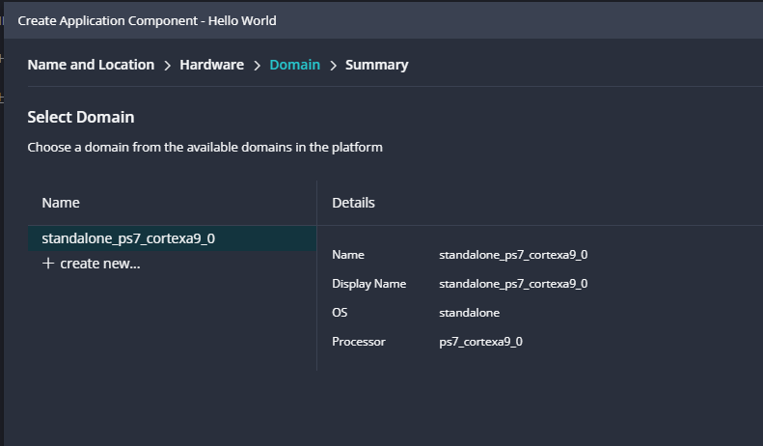

Finally, we are done going through menus, and our workspace should look like the provided screenshot. Containing two components in the workspace, the lab1plat, and the hello_world application. Finally! We can navigate into the hello world project and review the source code for the application. Not surprisingly, it prints “hello world”.

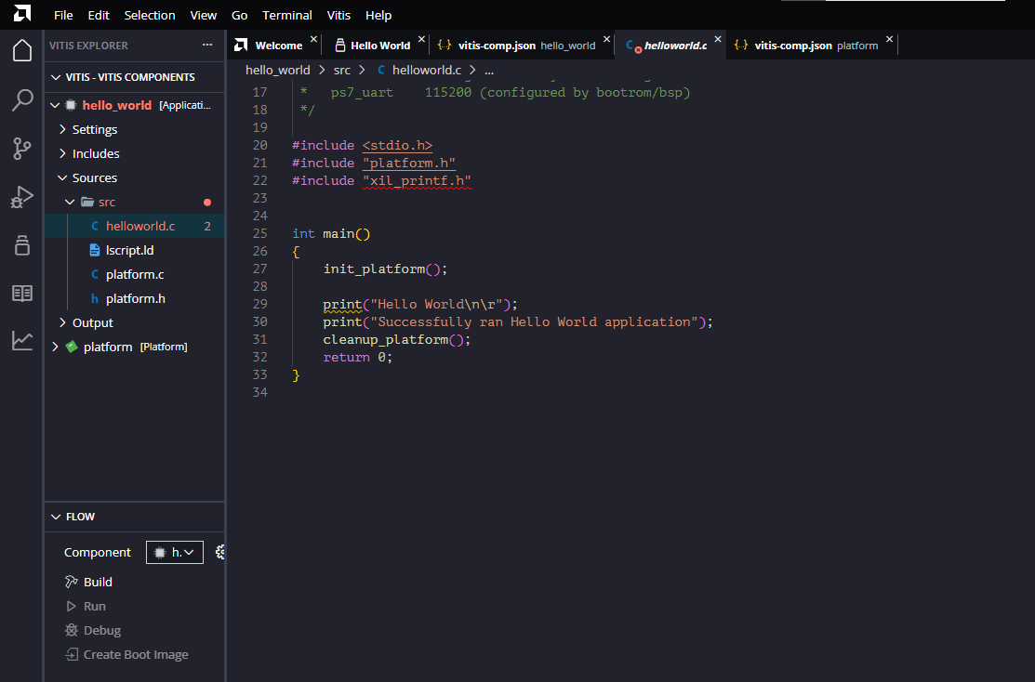

Now, let’s run the software and test if it works. Select the hello_world project and then select “Build” in the flow windows which is below your sources. The first time, you will be asked to also build the platform since that hasn’t been done. Select “Ok” and that software will be built as well. **Note:** This part takes some time but isn’t required to do again unless you change the hardware in Vivado.

At this point you have a software binary to run on the processor and a bitfile to configure your programmable logic from step 2. All the things necessary to actually run the code on the processor.

## Step 4 – Debugging

For this section you need your Zybo board. If you don’t have it yet, you can read ahead.

First, setup the Zybo-Z7 for operation. This will be as simple as a USB connection from your PC to the Zybo on the “PROG/UART” connector. This will provide power, an interface for programming the PS/PL, and a UART for terminal output. Using a terminal program of your choice (TeraTerm, MobaXterm, Putty…etc.) open a connection to the USB-UART bridge on the board at 115200 baud 8-N-1. **Note:** You may have other serial ports on your computer, so some strategic plugging and unplugging may be required to figure out which one is the Zybo. You will know you have the right one when you can type in your terminal program and lights flash on the Zybo next to the USB connector.

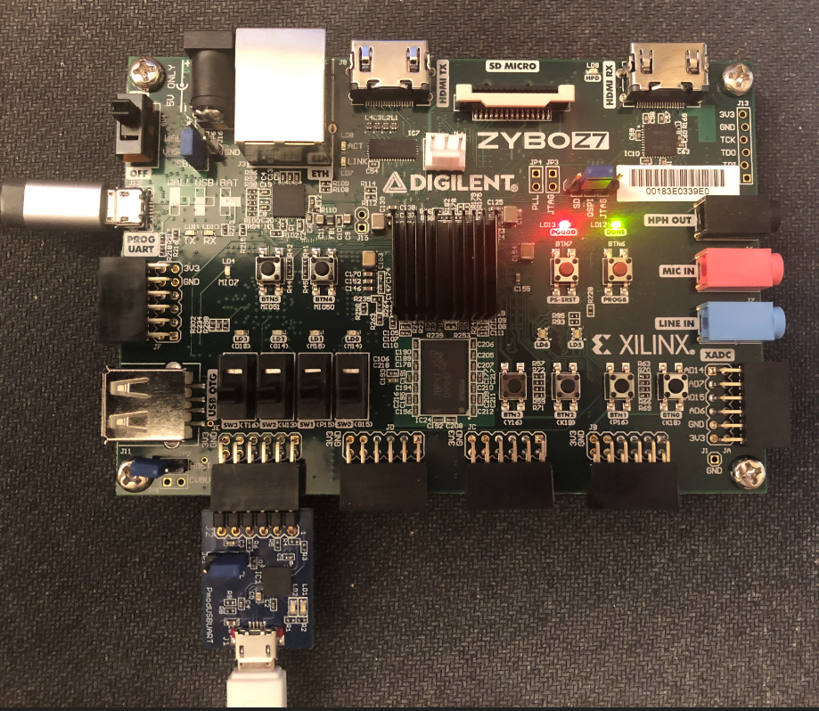

Before we can run our application, we need to program our PS and PL. There are a few ways to approach this between Vivado and Vitis but since we previously chose to export the bitfile from Vivado along with our hardware description, it will be easier. Because of that, Vitis is prepared to program both the PS and the PL for us whenever we debug our software. To learn more on this, select the little gear next to “Debug”.

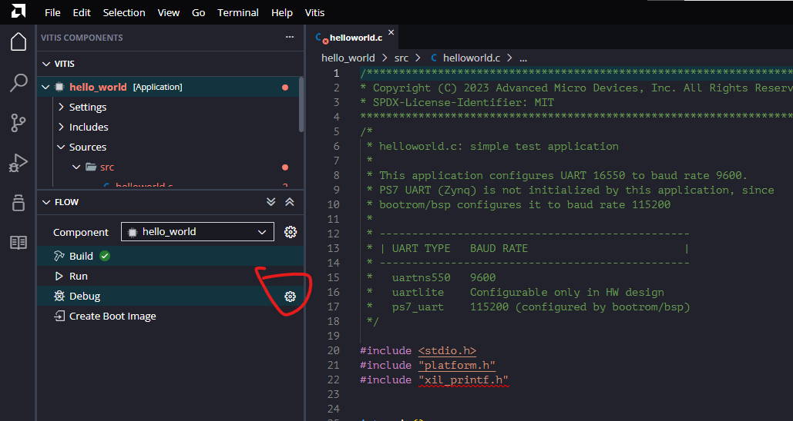

There you can learn where the tools are grabbing the bitstream from to program your FPGA PL before starting the debugging process. (See, a copy of your bitstream was created, and is now in the Vitis workspace… keep that in mind if you edit your hardware in Vivado. This copy was created as part of the Export HW in Vivado and the Create Platform in Vitis.

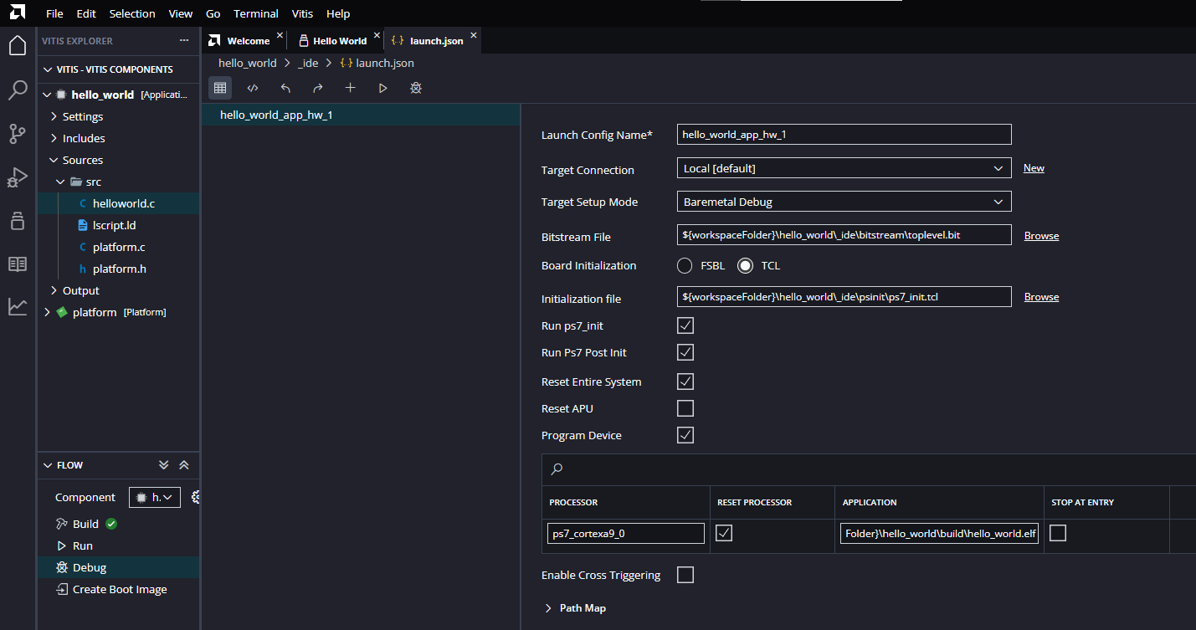

Now, instead of selecting the gear symbol next to “Debug”, select “Debug”, and we can actually run the program.

If everything works correctly the Debug perspective will open, the devices will be programmed, and your software will be sitting paused at a breakpoint at the beginning of the main function. Press the “Continue” button to run the entire program, or “Step Over” to run one line of main at a time. When the print lines run you should have the corresponding text in your terminal program.

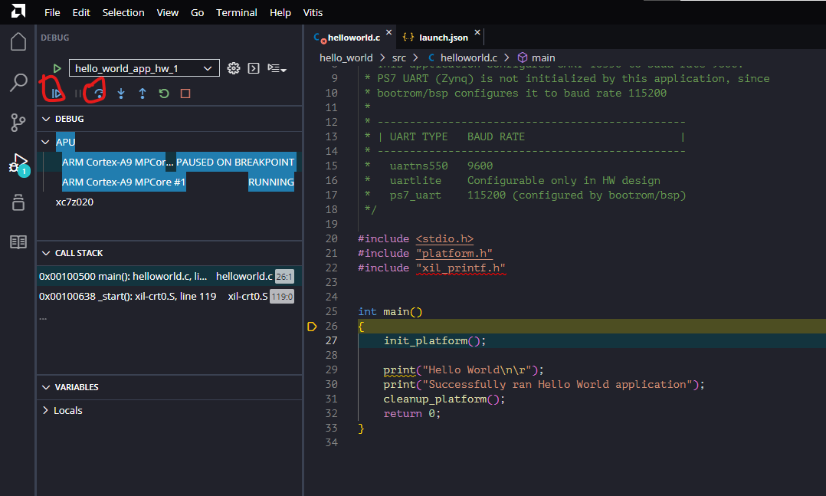

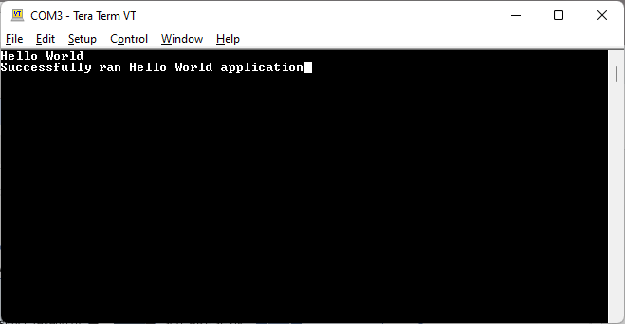

You did it! Now let’s figure out how to use the GPIO peripheral we included in our hardware design.

Let’s modify this program a tiny bit, and learn how to write the LEDs at the same time. Going back to hello_world.c - #include two new files:

* xparameters.h - This file contains a list of every peripheral in your system, parameters about it, its memory address…etc.
* xgpio_l.h - This file contains low level functions for reading and writing to GPIO.

Now, after the printing of hello world, add this line of code, which will write the value 2 to the DATA2 register in the DIPS_AND_LEDS peripheral, which we know is our LEDs.

XGpio_WriteReg(XPAR_DIPS_AND_LEDS_BASEADDR, XGPIO_DATA2_OFFSET,0x02);

**Save, Rebuild** and then run again to confirm that your LEDs are updated as expected. One of the LEDs, LD1 should be lit.

Lets try one more thing before we write some of our own software.

printf("DIPs read : %x\r\n", XGpio_ReadReg(XPAR_DIPS_AND_LEDS_BASEADDR,XGPIO_DATA_OFFSET));

This will read the current value of the dip switches and print it out in hex.

## Step 5 – Writing some custom software

Before we move on to other more mechanical things, let’s get some practice writing our own software. We know how to print, and read the dip switches, so we now have all the tools to extend this to our own custom program. This program should **start by printing your name and then once printing the current value of the dip switches. Then, the program should run continuously in a loop forever, monitoring the slider switches for changes, and printing the new value when (and only when) they are moved by the operator. (No debouncing or anything fancy needs to be done here, so if a change happens to cause multiple transitions to be printed to the screen, no worries). It should not be possible though for your software to miss a transition. This program that you have written will be what you demonstrate to show completion of this lab. Debug this software and make sure it operates the way you desire.**

## Step 6 – Booting from Flash

We have two options to boot our system (PS and PL) from flash. We can put an image on a micro SD card (included in your kit), or we can program an image into the QSPI flash chip on the board. Both methods will need the same product, a file named “BOOT.bin”, which our project is already set up to create for us.

Back at the home view, select “Create Boot Image”.

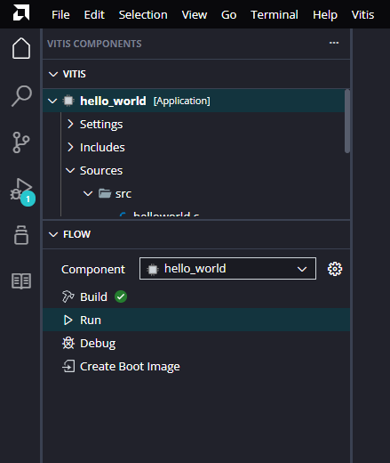

Which will pull up a dialog explaining the process. Nothing much needs to be changed in the next screen, but the output BIF file path may need to be filled in before you are allowed to proceed. If so, just click on “Browse” and accept the default. It will end up looking something like this:

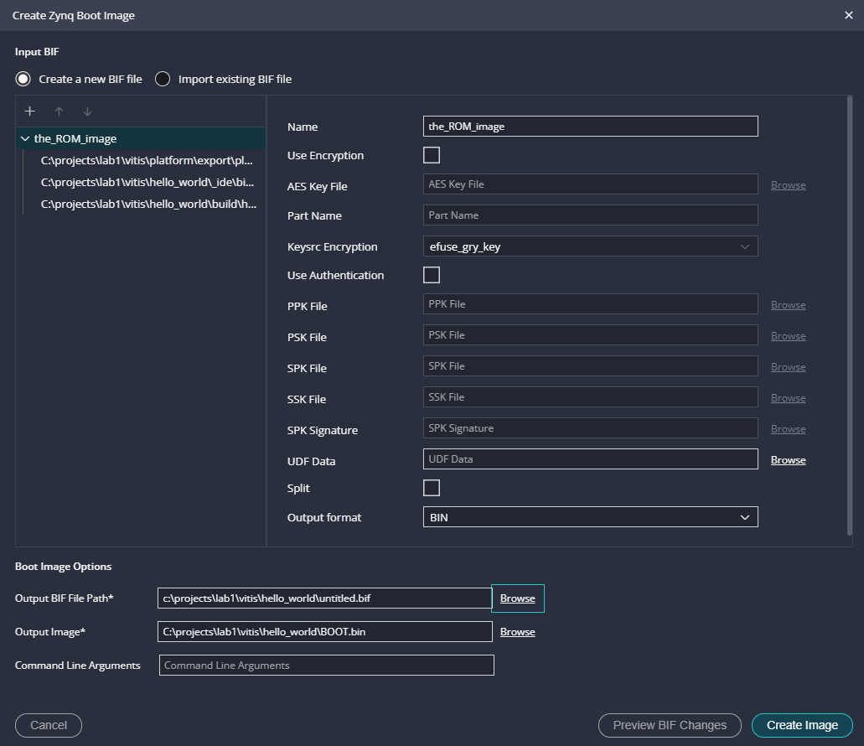

Take a minute before creating the image to see what files are being placed into the ROM image. It is packing 3 things into one file:

1. A “fsbl” or first stage bootloader
2. Our bitstream (the PL design)
3. An ELF file (our hello world software).

Now you can select “Create Image” to make the file.

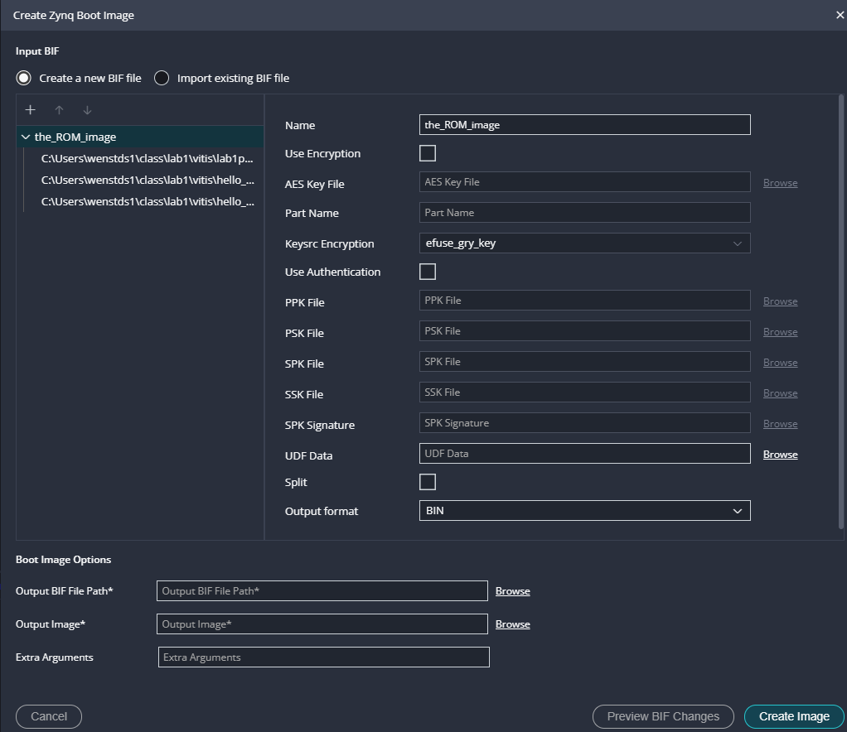

A little box should pop up reminding you where it went: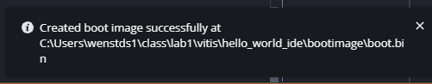

### Booting from SD Card

Navigate to the folder where your boot.bin was placed, and grab the boot.bin, and put that file in the top-level folder of an SD card (one was provided with the kit). Safely remove the card from your computer and insert it into the Zybo board. There will be a jumper labelled “JP5” on the Zybo that allows you to select the boot mode. Set it to “SD” – it was previously set to JTAG for our debugging. Then power off the board and power it back on. When you turn the board on the DONE LED will illuminate (indicating your PL is programmed), and then your software will run, printing to the terminal and your LEDs should be set just as they were when you ran the program from the debugger.

### Booting from QSPI

To boot from QSPI we need to program the same binary that was in BOOT.BIN into the QSPI flash chip. To do this, set the boot mode jumper to JTAG, and then power cycle your board. Select from the Menu Bar: Vitis -> Program Flash. In the “image file” field, browse to the boot.bin that you just created and then select “Program”. This process takes about a minute or so, and should indicate success when complete.

You can now power off the board, change the boot mode jumper to the QSPI position (middle two pins), and power back on. The DONE LED should illuminate, your printout(s) should be on the terminal, and the LEDs should be set just as you had when you ran from the debugger.

# Part V: Packaging for Submission

For this lab, you will not need to submit the entire project – only a single BOOT.BIN file which can be used by the instructor to test your Hardware/Software in action. When you put on an SD card (or in flash) it should print your name to the UART, and then monitor and report all changes to the slider switches.

**Important:** The on-board USB-UART converter is powered by the board, so when it goes off, your serial port will go away in TeraTerm. This may prevent you from noticing the welcome message when you power on the board, as the serial port won’t have reattached yet. Don’t worry about this if you don’t want. You can get a fresh restart of the board by hitting the Red “PS_SRST” button, which will boot the processor again. Another fix is simply to put a short delay in your program before printing the welcome message. I wouldn’t bother with this though.

1. If Vivado can’t automatically refresh from the repository you can use [Digilent board definitions/instructions to install manually](https://github.com/Digilent/vivado-boards).